COMPUTER SUPPORT OF CRISIS CONTROL – PART OF EDUCATION STUDENTS OF THE UNIVERSITY OF DEFENCE

Jozef Heretik & Jiri Barta

Keywords:
Information system, crisis management (control), crisis situation, interoperability, computer modelling, industrial breakdown and other accidents.

Abstract:
Part of university education students of the University of defence study module called „Civil protection“ consists among other things problems computer support of crisis control. Students of Bachelor´s and Master´s degree programmes are during their study acquaint with the Information systems of crisis control and with selected programs for computer modelling of possible impacts of industrial breakdowns and other accidents. In this paper will in more detail presented some of the products with which students work during their study.
These are:
- information system of crisis control "Emergency Office",
- programs for computer modelling VLNA (WAVE) and TerEx,
- simulator for crisis management training and exercising,
- products for interoperability of information systems during crisis situations.

1 Information system of crisis control called Emergency Office

Emergency Office (EMOFF) represents a set of tools and services suitable for the decision support at any levels of planning, command and control and other activities associated with the preparedness of the country, region or company to the emergency situations. EMOFF is targeted to support managers at various levels of command and responsibility and it helps to maintain the operational continuity of the specific area. Start screen EMOFF is presented on the Figure 1.

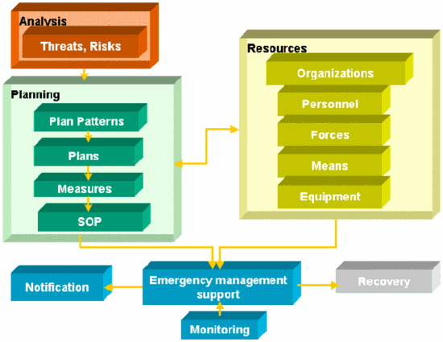

Figure 1 – Start screen EMOFF

From the initial emergency information, through the notification of responsible persons and agencies, up to the humanitarian and other activities – EMOFF supports the cooperation and interoperability of various persons, organizations and agencies. EMOFF enables sharing the information about the situation and resources, supervising the resources utilization, searching for specialists, issuing the messages, tasks and requests. EMOFF maintains a log of all operations and activities completed by users. EMOFF supports also the training of crisis managers, using the ESIM simulator. EMOFF is in principle multilingual, enabling the users to work with the information in various language environments, supporting thus the international interoperability.
Floods, mudslides, earthquakes, large industrial and traffic incidents, terrorist attacks, vast fires, epidemics, migrations, strikes, protections of employees, citizens and environment, business continuity planning, crisis planning.
The system supports all phases necessary for the good preparedness of an organization or company to handle emergency and crisis situations.
- Analysis – evaluation of assets and associated threats and risks,
- Planning – development of operating plans containing measures to optimally handle all predictable situations, mapping all the resources available to resolve problems,
- Management – automatic notification of predefined personnel or organizations, searching and deployment of personnel and resources, situation monitoring – current status of active procedures and measures, task management and compilation of situation reports for various management levels,
- Training of personnel – together with the ESIM (Emergency Simulator) system allows the training of the personnel in various agencies based on the predefined scenarios.

EMOFF modules

Organizations
The module is used to record information about agencies and organizations, which might play a role in emergency situations, or which may be for any purpose interesting for the managers and planners. Organizations may for example appear as suppliers of resources, owners of objects at risk or the hazardous ones, executive organizations providing measures in emergency situations, etc.

Personnel
The module contains information about personnel who can be somehow connected to the activities in all phases. In addition to the “standard” contact information, there are other parameters monitored as the knowledge, specialization and other skills, age, engagement in emergency management, training, medical examinations, etc. – i.e. attributes which may influence deployment of the personnel according to the specific conditions. Besides the personnel involved in emergency management plans (i.e. specialists, members of executive organizations and comities, etc.), the contact personnel to organizations and agencies can be also included to the database. Personnel module also enables to monitor personnel deployment to emergency situations and to provide their notification on any specific event, which can be set for them in the system.

Resources
The module Resources maintains the information about available resources (i.e. forces, equipment, etc.), which can be used during the response to the situation.
There are two main ways how to work with resources in the module:
- to plan their usage to provide measures (allocate the resource to the measure),
- modelling.
There are three main types of resources according to their characteristic:
- Resources – forces – human resources – organizational elements (fast-deployment units or teams),
- Resources – equipment – material and technical means,
- Resources – facilities – various buildings, shelters, accommodation and catering facilities, renovation and veterinary services, stores, etc.
The Resources module enables to record information about particular resources, to enter their parameters and to deploy them to the emergency situation.

Threats
The module enables to support risk analysis i.e. to determine possible emergency situations, their origins, possible causes and impacts and specification of objects at risk and hazardous ones.
The module has three main parts, which are interconnected:
- Threats – possible emergency situations, type, location, coordinates on the map, relation to the hazardous objects (i.e. can be the origin of the risk), relation to the objects at risk, perimeter and supposed impacts, number of persons at risk, description of hazard,
- Hazardous objects,
- Objects at risk.

SOP (Standard operating procedure)
The module supports design of SOPs and model plans for various emergency situations and for various management levels. Each step necessary to be performed in a specific situation can be described. If an emergency arises, the corresponding SOP is activated and EMOFF helps to record how the specific steps are carried out and to monitor the situation. EMOFF allows a predefined notification list of personnel to be linked to the SOP steps – it results in automatic usage of the Notification module whenever such a step is completed.

Measures
The Measures module allows planning of the whole series of measures, which should prevent the initiation of emergency situation, and in case the situation occurs they help to mitigate its impacts and to handle the response. The module Measures enables to process individual measures (to keep the summary, to enter and edit the new ones and to elaborate the individual steps of the measure). When managing emergency situations and monitoring their status individual pre-planned measures can be activated and assigned to the situation.
Types of measures:
- Measures – evacuation – measures to ensure evacuation of inhabitants,
- Measures – monitoring – characteristic and usage of monitoring systems,
- Measures – protection of inhabitant,
- Measures – emergency survival,
- Measures – shelters,
- Measures – warning.

Notification
The Notification module has several functions. On one side it enables to specify personnel and organizations to be notified and when it will be done. Such a list can be connected to the particular step of SOP or measure. The Notification module enables to record if and when the individual personnel were notified and if and when they confirmed the receipt of the information. It is possible to use also a group notification. Selecting a predefined list of personnel launches the automatic sending of e-mail or SMS message to all members in the list. The text of the message can be standardized in advance or edited by the user who launches the notification. Other function of the Notification module is the specification of so called automatic notification by EMOFF – the selected personnel are automatically notified when some activity in EMOFF is completed. The message can be generated for example when entering log about emergency situation, adding situation report or deploying personnel, etc.

Emergency situations
This module supports resolving and management of emergency situation.

The module enables:
- Entering of emergency situation (possibility to locate estimated affected area (based on the modelling software) and really affected area (based on situation report),
- Keeping a log about emergency situation – i.e. an information about all messages, situation reports, tasks, requirements, deployment of resources and personnel, etc. related to the situation,
- Possibility to activate the predefined SOP or measure and to generate the situation report,
- Deployment of personnel, resources to emergency situation,
- Activating the scheme of notification.

Mapping (GIS) module
The module allows users to attach all relevant information to a map. The basic functionality is:
- Using various maps and plans available (geographical, climatological, demographic, cadastral and other maps....),
- In principle locating any record in the system on the map,
- Selecting zones, areas, tracks and possibility to select the style of any object,
- Getting the detailed information about objects displayed on the map,
- Applying (displaying) results of modelling software,
- Analysis of the highlighted area on the map to determine for example number of inhabitants in municipalities located in highlighted polygon, resources available in the area etc.
The mapping module can work either with the local maps and GIS functions or use the net mapping services provided for example by the company Intranet, by the regional or national mapping institutions etc.

Recovery
The module is focused on recording damages and casualties and subsequently on generating reports to plan the recovery. It provides the information about affected area, responsible organizations, size of damage, damaged infrastructure, estimated and actual size of damage etc.

Administration Tools
The module contains the administration of user accounts and definition of access rights to the data in the system or groups of users. It also contains the administration of predefined pick lists used in the product in order to keep the data consistent.
2 Programs for computer modelling VLNA (WAVE) and TerEx

VLNA (WAVE)

WAVE is the software to calculate and visualize the flood breakthrough water wave and to model the consequences that resulted from the water dam destruction. The core consists of the model designed at the Military University of the Ground Forces in Vyškov (Czech Republic). Screens of program WAVE is presented on the Figure 2.
It can quantify the height of the breakthrough water wave depending on the distance from destructed water dam and on the character of the terrain (diagonal and longitudinal valley profile) where the wave proceeds ahead.
The model provides continuous information in graphical form. In MaGIS Professional Studio it is possible to display 3D view of affected area and both the profile of the terrain along the river and across the valley of the river.
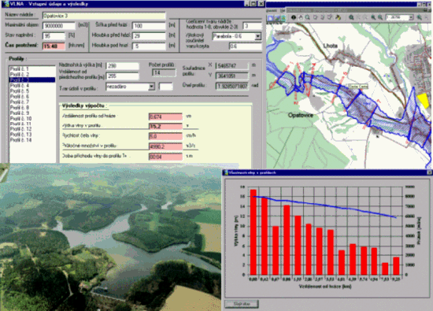
In longitudinal profile it is possible to mark the points with known height of flood breakthrough water wave from previous calculations and to finish calculating in other points by approximation. In 3D view it is then possible to represent the water level formed by flood wave in particular reach of the river by the curved area consisting of basic model elements. The area obtained this way is possible to display subsequently into two-dimensional map.
Figure 2 – Screen WAVE

TerEx

It is very easy for terrorists to misuse the industrial resources as “civil” weapons. The potential saboteur needs only to know, how for example to cause a release of the hazardous chemical material or how to damage its source and initiate a crisis situation. Due to human technical maturity and invention it is an important threat. There are many misused hazard resources in industrialized countries and they are very often located near human settlements.
In future we can expect increase of terrorist’s knowledge and creativity and that is why this problem is becoming important for industrial nations all over the world. The 11th September 2001 events might be an example.
TerEx is the tool for quick forecast of chemical materials and tripwire explosive systems impacts and consequences. Damage of society integrity is often the main goal of terrorist misuse of hazardous materials. The software model includes connectivity to graphic information system for direct results display in the map. Start screen of program TerEx is presented on the Figure 3.
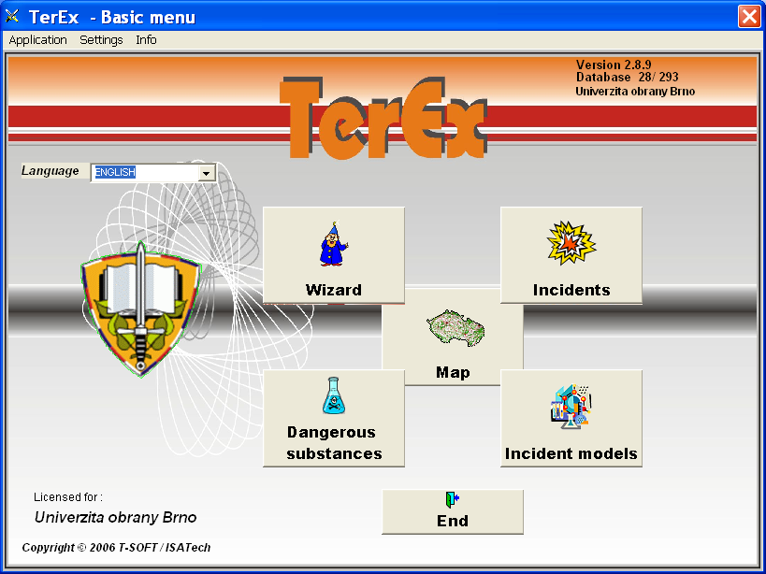
Figure 3 – Start screen TerEx

TerEx is aimed mainly for flexible use by rescue units during the operation to quickly determine the range of area under risk and to manage measures to protect inhabitants. It is possible to use TerEx by the operation commander directly at place or by operation officer in Command and Control Centre. TerEx is also very effective for planning and risk analysis. The model works even when not all input data are available. It is an advantage for use in stress situations.
TerEx provides evaluation of 4 basic accident models:
- TOXI model – dangerous toxic substance release – evaluates range and shape of cloud. Its shape depends on quantity and concentration of released material,
- UVCE models – release explosive temper material – evaluate incidental range of blast wave caused by detonation of escaped explosive material mixed with air, the following basic types are available:
  - PLUME:
    - Continuous gas release into the cloud,
    - Continuous release of boiled liquid with rapid cloud evaporation,
    - Slow pool evaporation into cloud,
  - PUFF:
    - Single gas release into cloud,
    - Single release of boiled liquid with rapid cloud evaporation.
- FLASH FIRE models – evaluate risk area of heat radiation caused by fire:
  - BLEVE – fire threat of reservoir,
  - JET FIRE – continuous massive gas release with blazing up,
  - POOL FIRE – pool fire or boiling liquid fire.
- TEROR model – application of explosive – evaluates incidental range of blast wave caused by detonation of explosive system.
TerEx is characterized by high comfort and easiness in use. It is possible to select parameters from menus.
TerEx meets NATO messaging standard ADatP-3. It offers also the output in text format or in XML.
The modelling tool is also equipped with the asynchronous stepping feature to support visual animation or connectivity to simulation system ESIM 2000.

3 Emergency simulator for crisis management training and exercising

The Emergency Simulator (ESIM) represents a set of software tools containing the basic information system for crisis management EMOFF and the simulation core. ESIM enables to create scenarios, to perform the own simulation functions with the basic information system and also enables the evaluation of running simulation courses. The simulation subsystem supports the user’s education, the training to solve the situation, the co-operation of different organizations and personnel and also the development of operational procedures and the implementation of integrity tests.
Based on the predefined scenarios the information is being sent and displayed to users via the simulator core. The information about the status of the progress is displayed. During the simulation the users can play various roles and their task is to learn how to respond the new situation in a correct and routine manner.
The instructor who is able to see all the students’ activities and to pause and discuss the situation controls the progress of the simulation. At the end of the simulation course, it is possible to evaluate the performance of the students and the quality of their co-operation. It is also possible to run the simulation course repeatedly or to correct the scenarios and to run them again. The functions of the system are based on process analyses in crisis management and on assumed requirements in information security and continuity of system operation. The system enables the cooperation of several organizations and agencies.
The basic information system EMOFF supports 3 basic fields:
- Risk analysis – the identification of hazardous entities and entities at risk, the identification of the threat type and the analysis of the impact on the inhabitants and infrastructure,
- Planning and creating standard operational procedures and measures, that are applicable to solve the situation and planning personnel and technical resources for the implementation of these measures,
- Response to the situation – notifying the defined personnel automatically, monitoring personnel and resources deployed to solve the situation, controlling the defined procedures and measures, task monitoring, generating incident reports, etc.
The system operates as the central application running on a secure server. Only the Internet browser (MS Internet Explorer) is required at the user side. The system security is solved modularly according to priorities (security goals) specified by system administrator.
ESIM tool is installed at training classroom at the University of Defence in Brno (Czech Republic).
The main advantage of this solution is, that users who provides the exercise to solve some situation, can work directly from their workplace via Internet and it decreases both time and financial costs of the exercise preparation. Also the possibility to perform international exercises is opened because the basic used information system EMOFF is multilingual.

4 Interoperability of information systems during crisis situations

Natural disasters, technological and industrial accidents, terrorism, traffic accidents are only some examples of situations and events which can happen and has to be dealt with in crisis management. These events do not avoid any continent, country, region, town or village, industrial or other object.

All these events can be characterized by basic attributes that specify the response:
- Type (for example natural disaster – flood, technological accidents – fire or dangerous chemical release, social catastrophe – terrorism, etc.),
- Size (affected area, number of affected inhabitants, etc.),
- Social seriousness (hazard exposure to one person, functionality of object, the whole society and others).

This categorization is very rough but it indicates who and how will be involved in response to the event. Especially in case of larger or more dangerous events there are many subjects involved in incident response and disposal of consequences. They have to cooperate and exchange information, we talk about of interoperability. There are several ways of information exchange, for example:
- Voice (personal contact, radio or telephone connection),
- Correspondence (document printout, fax, e-mail),
- Data exchange of information systems.

Different requirements on the technical equipment and on the level of exchanged information are made according to the way of communication. It is obvious that unambiguous, complete and up-to-date information always create a big advantage. But whilst in case of voice (for example telephone call) the participants can influence the contents and structure of the exchanged information by questions and explanations and they can “read between lines”, for electronically exchanged data the format of provided information has to be agreed in advance. Otherwise the information will not be processed.

Exactness, completeness and promptness of information about occurred incident can have dramatic influence on incident command, response and mitigation of negative consequences. In this respect information systems provide invaluable help, they manage to provide users efficient support in decision making. Plural “users” is appropriate because while with voice the information provider can address only limited number of recipients, then using data exchange between information systems the information can be almost simultaneously transmitted to a multitude of recipients. There is no doubt it is positive. Increased requirements on interoperability are the disadvantage – especially on technical, organizational and psychological aspects.

Everybody recognizes that interoperability is really necessary, but what is the situation in practice? While for voice and correspondence the situation is quite good and using of phone, fax, e-mail is a routine thing for majority inhabitants and the level of interoperability is given above all by the ability to provide complete, correct and unambiguous information, then the interoperability of information systems is still at a low level and it is still more pie in the sky.

There are several possible reasons:
- Technical incompatibility – although decreasing, still there are limitations due to for example different database types, communication transmission protocols etc.,
- Diversity of subjects and information they need,
- Absence standards of format and terminology of exchanged information and resultant diversity of “language” which subjects “talk” to each other (unlike terminologies),
- Organizational and psychological barriers like for example whose system or standard is better, whose investments will be preserved and who will have to buy the new one, who will have to adapt oneself to whom, etc.

Nevertheless there exists one sphere very similar to non-military crisis management and where the similar issues are dealt with for many years. And these are military information systems supporting command and control of military operations.

Military systems are the sphere where interoperability is dealt with for many years. Accepting some rules from the sphere of military information systems and adapting them to the conditions of non-military crisis management is one of the ways how to achieve interoperability.
Although some people will not agree, non-military crisis management has a lot of similarities with military operations:
- most of first response units (fire brigades, police, health service, etc.) have explicitly defined organisation structure with clear responsibilities and sophisticated command and control system (very similar to military one);
- command and control system is structured according to levels from the lowest one of “soldier” in the field to the highest countrywide one; at the tactical level local information are obtained by the officer in charge, commands are issued and received and on the highest level summarized information are collected serving as a base for conceptual and strategic decisions;
- logistics information about resources at disposal is kept, their utilization and deployment to incident response;
- it is vital to use geographic information system to visualize the situation at the “battlefield”;
- same as during military operations, it is not possible to rely on functional static communication means (Internet, telephone, mobile) during non-military crisis situation and responding forces has to be self-supporting in this respect.

And sure we could continue finding more similarities. Armed Forces deal with their information systems interoperability for many years both at national level (interoperability of systems for air, ground, naval and support forces) and international one (interoperability of multinational forces):
- at NATO level, there are workgroups with representatives from all member Armed forces (workgroups control respective standards they receive and make agreements suggestions for changes),
- there are two standards defined for information exchange –ADatP-3 formatted messages and LC2IEDM data model,
- Armed Forces of NATO member states have to adapt all their information systems to comply these standards (there are exercises regularly organised to test interoperability at various levels).
- Armed Forces are not forced to use certain products it is up to their responsibility how the standards and possible changes will be implemented into their information systems.

Standardization and interoperability exist in military systems already for tens of years it is not and was not an easy process, changes are often made slowly, but this is the only way how to ensure functional information exchange.

Other important reason why it is suitable to adopt experience form military systems is that also Armed Forces as such is involved (in some cases) in response to non-military incident and this trend continues. Also NATO prepares to include crisis management into the standards of formatted messages and data model.

Recently Europe more and more accentuates security and preparedness of state administration, private subjects, inhabitants on contingency management. The program for innovation, science and research support is also focused on that. At Framework Programme 7 (FP7) is a theme named Security where the dual use for civil and military purposes is accentuated. Standardization as well.
For needs interoperability information systems of crisis control is at the University of Defence in Brno used program IRIS from firm called Systematic Software Engineering (Denmark).
Next product used within the scope of interoperability at the University of Defence in Brno is instrument for distant wirelles transmission of picture and sound called „Interoperable terrain videoconference system of civil protection”.

References

HERETIK, J., URBANEK, J. F., PEŠKOVA, K., BARTA, J. Distant wirelles transmission of picture and sound – new aid in crisis management. In International conference „The 13th TIEMS Annual Conference 2006“. Seoul, 2006. Korea. 3 pages

HERETIK, J., BARTA, J. Počítačové modelování možných havárií s únikem nebezpečných látek – součást vzdělávání studentů studijního modulu ochrana obyvatelstva. In Sborník konference s mezinárodní účastí „Interoperabilita managementu ochrany obyvatelstva“. Brno, 2006. ISBN 80-7231-138-7. 10 stran

KUDRLOVA, M. a HERETIK, J. Interoperabilita krizových systémů v krizovém managementu. In Sborník mezinárodního kongresu „Interoperabilita v krizovém řízení“. Brno, 2007. ISBN 978-80-86633-91-6. 8 stran

T-soft [online]. Emoff. [cit. 2007-10-22]. Dostupné na WWW:
< http://www.tsoft.cz/index.php?q=en/emoff>

T-soft [online]. Vlna. [cit. 2007-10-22]. Dostupné na WWW:
< http://www.tsoft.cz/index.php?q=en/vlna-wave>

T-soft [online]. TerEx. [cit. 2007-10-22]. Dostupné na WWW:
< http://www.tsoft.cz/index.php?q=en/terex>

Department of Civil Protection, Faculty of Economics and Management, University of Defence, Kounicova 65, 612 00 Brno, Czech Republic, phone: +420 973 443 913, e-mail: jozef.heretik@unob.cz
Department of Civil Protection, Faculty of Economics and Management, University of Defence, Kounicova 65, 612 00 Brno, Czech Republic, phone: +420 973 443 435, e-mail: jiri.barta@unob.cz

