Simulation-based training of crisis managers

Ing. Michal Vaněček, Ph.D.
T-SOFT s.r.o.

Keywords: Simulation, Crisis Management, Interoperability, Models

Abstract

Synchronized simulation of distributed objects – SYSIDO and Model framework MOSIF, is a result of many years of T-SOFT company effort in the area of crisis management simulation systems and interoperability. It describes the philosophy and formal methods how to describe object as parts of reality, describing their activities, events and controlling of their behaviour.

The part of the project is about ensuring the compatibility with the Federation object model and how to expand it to the area of crisis management. The reason is the methods are currently being used in a development of a connection between crisis management simulator and the military tactical simulator. Even models (floods, chemical leakages etc.) are connected to simulation process on the real time basis.

Introduction
A unique working place intended for the instruction and training of crisis managers has been developed at the Military University of the Ground Forces Vyskov as a result of long-term concentrated activities in the field of crisis management. The classroom was built from 1999 to 2002 in co-operation with the firm T-SOFT s.r.o. Prague and it is equipped with high state of the art information technologies.

Lately, the fact can be observed more often that the people prepared in a satisfactory manner are a key to the successful coping with crisis situations. Under the circumstances when the considerable risk diversification turns up, the threat of a classical war conflict gives the way to that of terrorist pressure, the risk of using NBC weapons grows and unprecedented new forms of attack appear, the co-ordinate policy of military and civilian components becomes of greater importance. Equally, the importance of information and communication technologies increases for their support of solving crisis situations. At the same time, these technologies become a key element of critical infrastructure that is attacked because of its growing significance for the progress of the advanced society.

Within the framework of solving scientific and research tasks the theoretical and practical basis to educate qualified crisis managers has been created at the Military University. This basis can be used for both military and civilian students and can serve for instruction and training of multidisciplinary and interdepartmental co-operation on the levels ranging from districts to central organizations and international linkage.
The crisis management classroom based on up-to-date information technologies has been established. Both the products of significant world companies from e.g. the USA, Denmark and other NATO countries, and the programs of domestic provenience are used there. With the integration of all these systems which was implemented using NATO interoperability standards, with the completion of realistic national applications intended for crisis planning (such as ARGIS – the Civil Resources Administration System) the existing product is applicable not only within the Czech armed forces, but it can also be deployed by agencies, departments, regions and other bodies and organizations.

Since 2001 the crisis management classroom is available to remote users over the network (internet and intranet). Strong emphasis was put on the information security – several modern tools (e.g. firewall, chip cards) protect classroom from external attacks and unauthorized usage. Students are provided with set of digital maps and terrain simulation, NBC dispersion models, models for special floods caused by terrorist attacks, explosion models etc. Due to solution complexity the classroom is regarded as World Class. It is evident from contacts of our members and those of similar institutions over the world and opinions of our foreign guests.

Beside that, the unique tool and methodology for simulation interoperability has been developed. This methodology is called SYSIDO and it can serve as a base for simulation framework definition.

Later on, the modelling framework MOSIF has been designed, as a base for the further development of simulation and modelling systems.

Overview of the SYSIDO
Synchronised simulation of distributed objects; the name of it seems to be rather complicated. In fact, simulation system is a complicated area. If we have to find a solution for:
- Connecting two or more simulation systems,

- Connecting various models to the existing simulation system,

- Build distributed simulation system from components running in different environments and different locations,

We have a set of complex tasks.

If we think about simulation systems, we usually imagine the motion of vehicles, tanks, submarines or flight simulators.

The effort of T-SOFT Company has been targeted mostly to the civil area; we have been working mainly on the information support for the crisis situation decisions.

This paper is about how we tried to find a system solution for the issues above in specific cases.

Simulators and models
The Crisis management simulator is based on the set of scenarios, which simulate the behaviour of users-crisis managers. In the real situation managers are supposed to be connected together by the common information environment. The commercial products – EIS/InfoBook, Emergency Office etc, represent this environment.
There is a simulation engine behind those products, enabling some of the roles (users) to be simulated.

Basically, the decision and information processes are simulated in those situations. Simulator does not support any low level motion of vehicles; it supports only high-level processes.

On the other side, there are simulators, for example tactical ones (Kibowi, ModSAF), which could be used in the civil area. The only issue is how to combine real time processes in the field and high-level information processes.

Models are usually separate subsystems of larger systems. Simple models are usually calculating the worst situations in case of chemical accidents, floods etc. But they might be integrated to the decision simulation on the real-time basis.

Goals of SYSIDO
The basic goal of the SYSIDO project was to develop a standard, which defines approach and methods for a simulation system definition consisting of several subsystems, either standalone simulators or modelling systems.
This general goal was subdivided into the sub goals:

- To define the philosophy, the approach to those issues
- To define the formal tool for simulation system description
- To design the pilot system implementing the theoretical definitions
- To test the solution at least on ESIM2000 and modelling systems

SYSIDO Solution

The basic approach
The basic philosophical approach was based on following ideas:

- Any system or subsystem can be divided into objects. Objects have features - attributes and they are able to perform Activities.
- Activities of objects modify objects attributes.
- Activities are „switched-on“ in case of specific event.
- Event is generated by the central system (SYSIDO) or can be generated as a result of some object activity.
- The Kernel – the SYSIDO system, controls behaviour of all subsystems.
- We would not modify the existing systems. SYSIDO would just keep the definition of their functionality, describing it by the decomposition to the objects and their activities and other features described above.

When we designed the structure of attributes and other principles, we took the available standards (mainly the Federation Object Model) into account.
Based on the ideas above, the basic principles has been accepted:
- There are existing simulation and modelling systems. SYSIDO can link them with other systems in case they can somehow make one simulation step on demand. That means for example: Modelling system can make one simulation step in a time slot, it can simulate each 10 seconds the leakage of chlorine and, for example it can simulate one minute of accident in those 10 seconds.
- We cannot force anybody to modify his system. The only thing necessary for linking it to the SYSIDO is to accept some basic communication interface between the system itself and the SYSIDO.
- SYSIDO is „the central brain“, which takes care of object definitions, their attributes, activities and events they can produce. Systems themselves can reside somewhere on its machines, there must be only a connection between systems and the SYSIDO system.
- The formal definition must be independent on current technologies. The formal description of the simulation system can be implemented „here and now“ based on current technologies (File exchange, XML, .NET technology etc.)

If we are talking about SYSIDO, we can divide this term to several parts according to the goals described above. SYSIDO is:
- Basic approach and methodology
- The language for simulation system description
- SYSIDO Kernel – the software package taking care of system definition and simulation synchronisation and control
- Interface necessary for communication between SYSIDO Kernel and subsystems

Usage of SYSIDO
Any process evolving in time can be described by the SYSIDO methodology.
There are lot of examples:
- ESIM2000 vs. models
- Car simulation
- Financial simulation - cash flow, risks etc.
- Reservation systems
- Biological processes

Most of them were just defined in SYSIDO language, not practically tested. But we did it in order to be sure the approach is general enough and can be used in the multidisciplinary environment.

Example of SYSIDO usage
As an example the connection between the simulator ESIM2000 and the modelling system WAVE can be described.
The ESIM2000 system is based on the Emergency Office software, which serves as a complete support for crisis management decision process. Behind this system is the simulator – the engine running scenarios, which simulate the roles - persons taking part in the crisis management process.

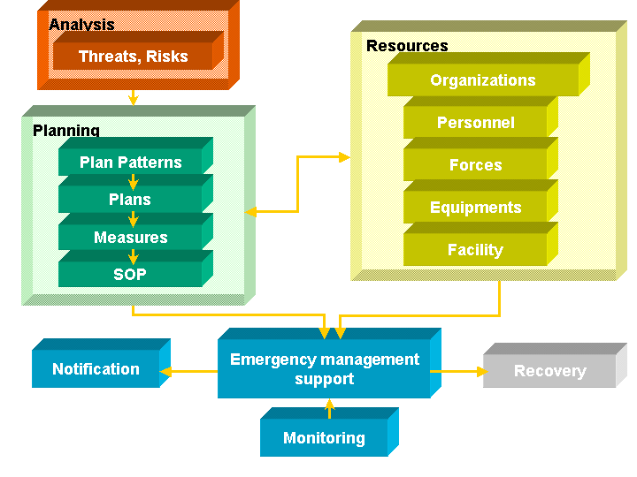

The WAVE model has been designed for modelling of dam destruction, when a destructive wave goes down from the dam. The system enables also the animation of the whole process.
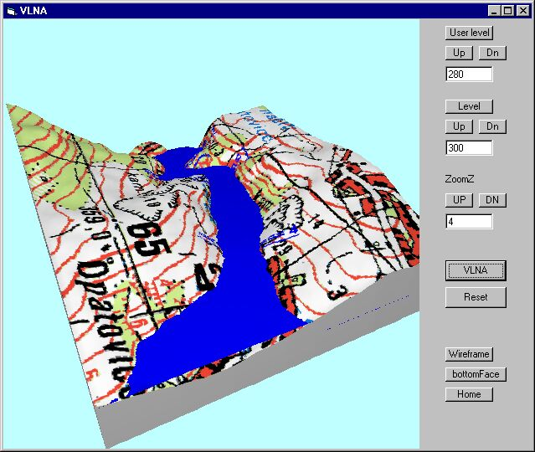

During the simulation of the decision processes it might be useful to have the real-time information about the accident.
This was the first part of the task; we connected those two systems through the SYSIDO system. The ESIM and WAVE were defined as Objects. The SYSIDO definition language defined attributes, activities and events of both objects.

Another feature of the connection is the possibility of feedback from the modelling system to the simulation.

If the wave reaches certain place or destruct, for example, specific resources, such a situation can be handled by defined handlers and produce events, which can run specific activities during the simulation process. That means scenarios can be modified by events, which are generated according to the configuration of the model or several models.

The very similar situation is modelling of the chlorine leakage. The following picture shows the part of the task, where motion of cars is simulated by a separate system, chlorine plume is modelled by the TEREX system, and the ESIM2000 simulator simulates the decision process. The SYSIDO system takes care of the process synchronisation and sends feedbacks from models to the simulator.
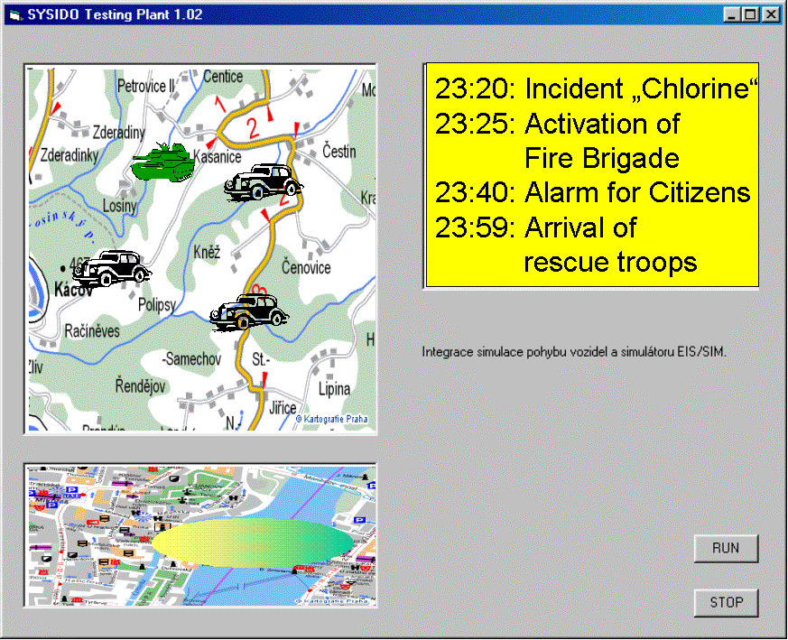

The goal = modelling and simulation framework
The goal of the Modelling Framework methodology (MOSIF) is to design the framework for information systems implementation, oriented especially on the framework for modelling and simulation systems integration.
The goal is based on the request to make such a specification for the crisis management area. We will base the philosophy on this specific area and then we will try to generalize the conclusion for other problems.

The design has several levels. On the lowest level it can be implemented by the HLA tools. Then we can use the SYSIDO concept for the integrated definition, but nevertheless the concept has to be covered by the some kind of the higher principle, oriented on the specific set of tasks, mainly model integration and interoperability tasks.

MOSIF Modeling Framework Summary

What is the „modelling framework“ good for?
It is a method, how to modify existing models, simulators, algorithms etc. in order to be fitted into the integrated system.

If we have a model X, what is to be done in order to do that?

- The model must be able to make a calculation steps in a defined time scale or time slots
- The model must accept the central management of the data which are to be communicated with other subsystems
- Each activity of the model must be controlled from the central „kernel“ of the system
- That means.... the core, the calculation „black box”, which is the most important part of the model X need not to be anyhow changed, the only necessary change is probably the logic of external control and data management

The typical system for which the framework is being designed has following attributes:

- It processes discrete event in a time frame
- Internally it is composed of modules, providing various system functionality
- Those modules can be implemented and run on one machine on in the wide area network like a distributed system
- There are two typical extreme kind of system-user interaction:
  - System events and status changes are totally dependent on the staff activities
  - System events and status changes are totally simulated and the user makes just the observation

Modelling Framework is a set of entities and rules for definition and integration of information system, based on the existing database, modelling, simulation and communication systems, the basic characteristics of which is they perform the sequential steps in time slots.
The basic entities are:

- MOSIF as an „logical umbrella“
- SYSIDO – the concept of the synchronised simulation of distributed objects
- Implementation of the SYSIDO either in pilot implementation or based on the HLA or other tools
- Methodology for interface implementation of the SYSIDO for the existing systems
- Description of the designed system in the SYSIDO language and its logical verification
- Subsystems with the SYSIDO interface
- Data base SYSIDO, the storage for all the data and their attributes
- Repository for swapping the real time and simulated time situations
- Interface for standard format information messaging
- Security
- Verification of the design

Why Modelling Framework?
Because:

- Ordinary real systems, serving for any phase of the crisis management, usually operate with time scale, but there is no need of central data storage and central synchronization
- Simulation system on the other side calculates with such a type of the architecture, HLA, SYSIDO or any other.
- In the real time run of the information system there might be an advantage, if we can in the time T to lay aside the real operation and run the speeded up situation prognosis or follow concurrently the trend of the accident on models.

.... Then we need

- Join the data of running systems in order to ensure they can exchange semantically understandable information (can be based on ADATP-3 or any other standards)
- Synchronise different systems in time and enable central Kernel supervision, even if it only every minute runs object activity, which will monitor status of each subsystem.
- Hold all the systems in the status of preparedness, when they can run for example modelling based on the user demand

HLA together with the SYSIDO are primarily oriented on the implementation of the simulation systems. In the real practice we can meet the request to combine the real time system with the modelling or simulation system, which can serve as an information support, either for standard operation procedures definition or for the prognosis of the situation trend.

Typical situations

Modelling and simulation – strategic games
Let, for example ESIM is a simulation system, designed for simulation of the scenario situation. Let us have then modelling system TEREX, which can simulate chemical accident in time. Using the SYSIDO concept we can such an integrated system describe and synchronize its run centrally by the SYSIDO Kernel.
This approach enables concurrently to the scenario simulation follow the chemical accident modelling in the range of the defined time segment.

Decision support
Let us have any kind of system dedicated for the real usage, for dispatchers etc. (f.e. EmOff, ARGIS, etc.).

During the planning or response phase we can easily get to the situation when we need the prediction how the situation will evolve in the near future.

For that purpose the system status should be „frozen“, swapped into the repository. Then, the simulated time can be started and the calculations, models, simulation can be done.

After evaluation it is possible to return back to the real time operation.

Conclusion
I have presented several areas of simulation and modelling issues and tools. Of course, it is not so easy to connect things together a make them to be easy.

There is specific solution working in University of Defence in the Czech republic, which is based on principles I have tried to explain. Further development of SYSIDO and MOSIF can be potentially useful for the area of simulation and modelling systems, which are used in education.

References
Vanecek, M: Synchronized simulation of distributed objects, Ph.D. work, 2004.
Author Biography
Ing. Michal Vaněček, Ph.D. works as the managing director of the T-SOFT s.r.o. Company, Praha, Czech Republic. He has been the project manager of several projects for MOD and designer of crisis management simulator. He has the Ph.D. degree in the area of simulation interoperability.

