Radiochemical Contamination Analysis of Ob-Irtysh River Basin Based on Geoinformation Approach

G. Kochergin

Ugra Research Institute of Information Technologies

V. Migunov
Radiation Safety Department of Khanty-Mansiysk Region

Y. Polishchuk

Ugra State University

A. Trapeznikov

Institute of Plant and Animals Ecology

Keywords: Cluster Analysis, Geo-information Systems, Radiation Pollution, Radiation Safety.

Abstracts
The paper presents the results of multidimensional data analysis on radiation water pollution and river bottom deposits in two largest rivers of the Western Siberia. The analysis was carried out using geo-information approach based on combination of statistical methods and spatial analysis. The analysis revealed the spatial patterns on radiation pollution of the Ob-Irtysh river basin and detected radionuclides that cause the largest pollution.

Introduction
The radiation situation in Western Siberia territory of Ob-Irtysh river basin is mainly determined by the transboundary transport of the radionuclides that get into the environment from the different sources. Such sources are, first of all, Semipaltinsk and Novaya Zemlya nuclear testing grounds, and, secondly, fissile materials production enterprises located at the Ob’–Irtysh river basin: Siberian chemical plant (Seversk City near Tomsk) and “Mayak” plant (the Chelyabinsk region).

It is known [1], the most dangerous radionuclides for the human health are caesium-137 and strontium-90, because their half-life periods (about 33 and 28 years accordingly) are comparable with the average life expectancy of the human being. That is why the objective of this work is to reveal the regularities of the spatial distribution of caesium-137 and strontium-90 in the river water and river bottom deposits of the Ob’–Irtysh river basin. The points at the Vakh and Northern Sosyva rivers – inflows of the Ob’ river – were chosen as the background points of control over the radioactive pollution level.
Methodical Problems of the Analysis
The approach based on combination of the data spatial analysis with use of geo-information systems (GIS), the principal component analysis and the cluster analysis is proposed for the data processing of the rivers’ radiation pollution. These methods are used, because objects of the study have clearly-defined spatial properties, i.e. location of each object and the order of all objects are known. If there are insufficient quantitative data, the spatial information recording can help to receive more complete conception about the studied objects. Use of statistical methods of analysis is explained by the multidimensional nature of data. In this case, the unsupervised classification of data is aimed at object division into the classes with homogenous properties and used if there is insufficient a priori information about the studied objects. The principal component analysis allows studying the interrelations between the variables and giving the causal interpretation of the received results. The principal components are the convenient integral figures, because they reveal the internal regularities that are not directly observed.

Data processing and analysis were carried out in the following sequence: the unsupervised classification was carried out at the first stage, data processing by the principal component analysis took place at the second stage, and the spatial analysis of the results received during the first two stages was carried out in ArcView GIS 3.x environment at the third stage.

Data Description and Analysis Results
The analyzed data are the array that includes 4 measured parameters – volumetric activity of caesium-137 and strontium-90 in the river water and bottom deposits. Samples were chosen at 16 points.

During the data analysis by the above-described scheme classification was carried out by the method of the further neighbour. During the classification by this method each object is considered as a one-point cluster; objects are grouped consequently by the following rule: two clusters are united if the largest space between the points of one cluster and points of another one is a minimum one. As a result of the cluster analysis 16 sampling points were divided in three classes. The visual presentation of the classes on the digital map is shown in fig.1.

Testing of classification adequacy was carried out at the second stage, and at the same time each class was considered as a separate data array. The principal component analysis of the received arrays allowed to calculate the confidence intervals for the 1st and the 2nd classes with probability at 95%. It is impossible to calculate the confidence intervals for the 3rd class that consists of just 2 points. Fig. 2. shows the results of three data arrays analysis received at the first stage in space of two principal components. It shows that confidence intervals for the 1st and the 2nd classes are not overlapped, and the points from the 3rd class do not get into these intervals. It allows to make a conclusion about the statistical difference between the received classes.

Fig. 1. Presentation of cluster analysis results

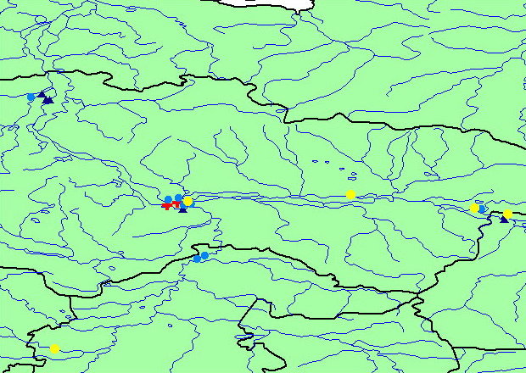
Class 1
Class 2
Class 3
Little Ob
Nothern Sosyva
Ob
Vakh
Khanty-Mansiysk

Tyumen

Nizhnevartovsk
Strezhevoy
Surgyt

Fig 2. Results of classes’ analysis in the principal components space

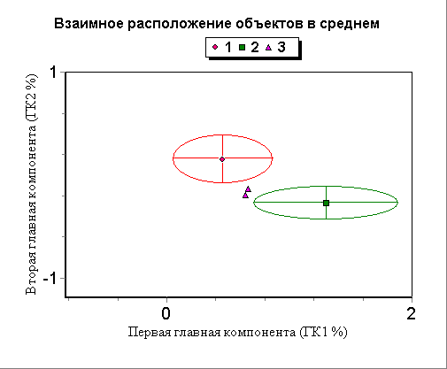
First principal component
Second principal component

Table 1 contains the calculations of the average values of all parameters for each class. It shows the objects that have the maximum pollution level in the bottom deposits came into the 3rd class after the classification. This class contains two points: in the Ob’ river, 5 km above the outfall of the Irtysh river and 15 km lower the Irtysh outfall. According to the table 1, the first class has the higher strontium-90 content in water and bottom deposits, and the second class has the higher caesium-137 content in water and bottom deposits.

Table1. Average values of parameters for each class

Class number | Water |  | Bottom deposits
Class number | Cs–137 | Sr–90 | Cs–137 | Sr–90
1 | 0,00117 | 0,03331 | 0,31667 | 3,57778
2 | 0,00170 | 0,02204 | 0,46542 | 2,22917
3 | 0,00116 | 0,03284 | 1,89000 | 4,01667

The data processing by the principal component analysis showed that the first principal component (PC1) contains 77% of original information. Largest impact on the first principal component is made by the 4th parameter – strontium-90 content in the bottom deposits (fig. 3). Because of the fact, that the first principal component considerably exceeds the value of the second principal component, the 4th parameter makes the largest impact on such division of objects into the classes. The second principal component can be excluded from the further consideration because of its small value in comparison with the first one.

Fig.3. Ratio of parameters in the first principal component
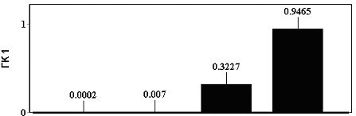
Ratio
Sr-90
in bottom deposits

Sr-90
in water

Cs-137
in bottom deposits

Cs-137
in water

Furthermore, it is interesting to trace the way of the first principal component changes during the consequent transition along the sampling points located up-stream in the Ob’ river basin. The graph of such dependency is shown in fig. 4.
Fig.4. Change of the PC1 value in the sampling points in the Ob’ river basin

The graph shows that the first principal component has the maximum value in point 6 (in the Ob’ river, about 15 km lower the Irtysh river confluence where radionuclides’ discharge transported by the Ob’ and Irtysh rivers is summed up). Then the value of the first principal component is decreasing again that shows the decline of radioniclide content in water and bottom deposits. The points 3 and 11 that are the points in the Vakh and the Northern Sosyva rivers have the lowest values of first principal component. It proves the adequacy of their choice as the background ones.

Conclusion
The paper shows the use of geo-information approach for the comprehensive data analysis about the radiation pollution state based on combination of statistical and spatial analysis methods implemented with use of GIS technologies. Two methods of the statistical data analysis were used: the principal component analysis and the cluster analysis that allowed to carry out the comprehensive analysis about the river basin radiation pollution state and to reveal some regularities. It is shown that strontium-90 in the river bottom deposits makes the biggest impact on the radiation pollution level of the Ob’–Irtysh river basin. The class of objects that includes two points – in the Ob’ river, 5 km above the outfall of the Irtysh river and 15 km lower the Irtysh outfall, was revealed. This class has higher average level of the river bottom deposits pollution in comparison with other classes.

References
V. Starkov, V. Migunov. (2003) Radiation ecology – Tyumen

G. Kochergin, T. Peremitina, and Yu. Polishchuk. (2003) Methodology of the comprehensive analysis of multidimensional data with use of GIS, cluster and component methods (2nd International scientific-practical conf) “Ecological-geographical problems of nature management of oil and gas regions” Nizhnevartovsk
V. Migunov, A. Zhilkevich, and Ya. Chubarov (2002) Radiation situation, Information bulletin “About the environmental state in the Khanty-Mansiysk Autonomous Okrug in 2001”, – Khanty-Mansiysk

V. Dyuran, P. Odell (1977) Cluster analysis, Moscow

