Case Study: Quantitative BIA for Business Continuity

Lee, YoungJai

Professor, Dongguk University, yjlee@dgu.edu

Lee, SungJoong
Team Manager, Lotte Data Communication Company, tagging@empal.com

Keywords: Disaster, Recovery, Quantitative RA, BIA

Abstract
This research was performed on IT risk assessment and Business Impact Analysis (BIA) for Honam Petrochemical Corporation (HPC). It was carried out 4 months, from Aug.04 to Nov.04. The research showed the Recovery Time Objective (RTO) and Recovery Point Objective (RPO) in constructing Disaster Recovery (DR) center and their Cost-Benefit Analysis (CBA) data through IT risk and BIA, which is for IT business continuity.

For IT business continuity of operation, the research is aimed to do IT risk analysis, perform BIA, deduce preferentially manageable IT risk and make quantitative results data from its size, so that indicator for the risk response and management can be obtained. According to risk classification criterion of NSA (National Computerization Agency) and risk classification model of Dongguk University Risk Management Institute, we computed the priority rank of risk management and diagnosed the risk management type for the organization after we evaluated Emergency and Influence of controlled or out-of-controlled risk.

HPC had been using SAP R3 as Enterprise Resource Planning (ERP) system, therefore, it was a situation that is possible to classify the systems as 144 work process units. We broke and computed 166 unit operation modules (144 of ERP processes and 22 of Legacy system processes) into 10 unit systems and 22 main modules, then performed quantitative analysis with the Process Impact Decision Tree technique after the analysis of correlation between them. IT asset value, computing cost, sales profit, direct personnel expenses, department cost on last year’s financial data are used as a factor of value assessment for Quantitative Analysis of 22 main modules. Then we quantitatively estimated values base on the amount of work and impact in processes by using the results driven by the survey.

We calculated value of process modules, value of operation modules and quantitative business impact by BIA. Then RTO and recovery priority of process were produced form analysis of relation on down time and damage of modules.

Introduction
HPC is a NCC (Naphtha Crack) production company, one of affiliated company of LOTTE enterprises and it has selling scale of 1 Billion US Dollar per year. HPC has the head office in Seoul and operates petrochemical plant, which is vertically interrelated in Yeo-su. HPC has the size of 1,000 employees hired, and as the DR system on the main IT systems is constructed at fourth quarter of the year 2004, Risk Analysis and BIA research are preceded as a unit project for prior stage of main project.

For HPC IT risk evaluation and BIA, the research was performed for 4 months from Aug.04 to Nov 04. This research was done with surveys, interviews, existing systems and data analysis. And the scope of the research and the target for analysis was limited for IT process of HPC head office and the plant.

Through the research, we classified the main IT risk and analyzed its causes and alternative plans. Also, through the quantitative business process, we were able to propose the meaning of unit system and its construction of DR center, also proposed RTO and RPO in between the construction of DR center, so we could finally show the CBA.

Research Method
To build the continuity of IT operations, we deduced highly prioritized IT risks which are need to be managed by performing IT risk analysis and BIA, so we made an indicator for risk response and management after we measure the scale of each of them.
IT risk analysis for such research used the base model introduced in trouble management guide by KOREA NCA and assessed the risk emergency and influence, and finally computed the priority ranks for the management risk and analyzed the causes by using them.

HPC is decided to do impact analysis for each process based on ERP system process. For the quantitative analysis for 22 modules, the value deduction factors are classified as IT related asset value, IT related cost, business profit, direct personnel expense, service cost, personnel and team expense, which are based on 2003 finance data. Therefore, the results from interviews and surveys are analyzed, and the costs are divided according to personnel process workloads and their business impacts, also the values are quantitatively deduced.

The value of each process module used BIA quantitatively and calculated the value for each work module accordingly, so we could deduce quantitative business impact and analyze the downtime of process modules and connected damage, finally introduced the prioritized ranks of business recovery in between the construction of DR center and RTO. The validity of investment and its ROI were able to deduce by the CBA, which obtained from this research that in between HPC DR IT center construction.

Data Analysis
We classified the criterion of risks by interviewing related people in HPC in a basis of the classification for IT system disaster and trouble, which released by KOREA NCA in the past. IT risks analyzed in this research, are divided in two main categories, feasible and non-feasible controls. On these categories, survey technique is used to obtain influence/emergency rate, so final 14 prioritized risk management targets are deduced.

For those 14 prioritized risk management targets, IT system damage risk by (building) fire is included in non-feasible controls. Feasible control included system destruction/abstraction, computer virus damage, hacker intrusion, and fault on communication router, network device error, database (system) error, server operating system error, application program server error, MDF trouble and UPS trouble. Also, the violation of physical information system access control risk and resource outflow risk are added for extra from the result of the survey.

To build continuity of IT operations and to find out the ROOT cause of 14 IT Risk management targets, we used a technique commonly called, fishbone. The fishbone helps to visually display the many potential causes for a specific problem or effect. It is particularly useful in a group setting and for situations in which little quantitative data is available for analysis.

Therefore, the obtained results of the root causes are used again to perform the second analysis, matrix analysis with those 14 IT risk management targets to deduce preventive measures assessment, and so the risk preventive strategy is established. Therefore, HPC deduced the future tasks for IT risk management, so they were able to prepare the plan to build with the grade under the mid-long term plan.
It was a situation that R3 from SAP was used in HPC as ERP system and process innovation consulting was previously done by Deloitte & Touche. So it was possible to divide 144 operation unit processes.

Therefore, through the 144 operation unit processes of ERP and Legacy system as shown in Figure 1, the part that is not able to verify with those reference data, site operator wrote up directly. And for those processes that no manpower was involved, were excluded. Also, those processes with insignificant manpower expend, were integrated with similar processes.

Figure 1: HPC System Constitution
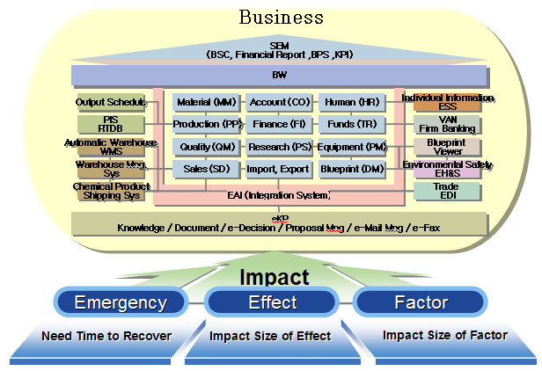
As we defined the analysis target like above, classified ERP unit operation module as 107 modules, and 52 processes extracted from 12 Legacy Systems, the total 152 main modules were deduced and decided to perform the operation impact analysis (Figure 2).

Interviews and survey are performed by distributing questionnaire to 20 related operation teams, 120 system core users using those target ERP processes. To do that, personnel duty analysis and process analysis were previously performed, and also before/after process interrelation analysis in between each process were performed as well.

Figure 2: Process Value Calculation Steps
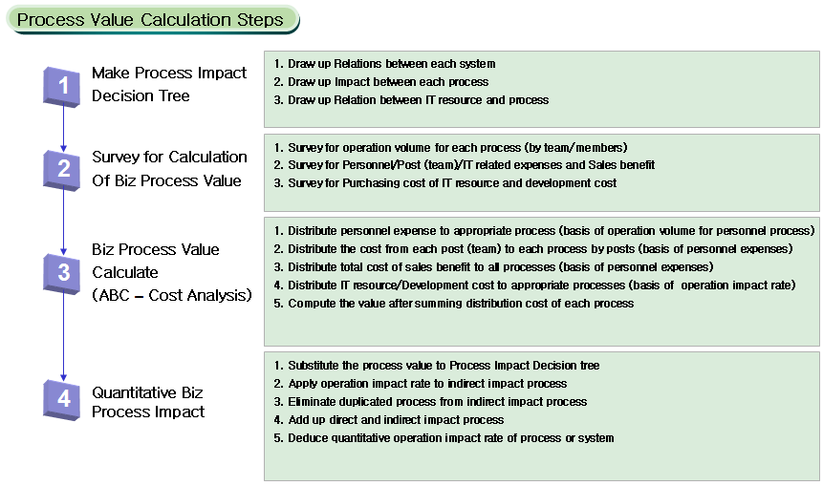

For the Process Impact Decision Tree analysis, system interrelation, process impact and IT resource/process interrelation were drawn up (Figure 3). Therefore, the basic research was performed for the process value and operation dependence of each operation.

Figure 3: HPC System Relations
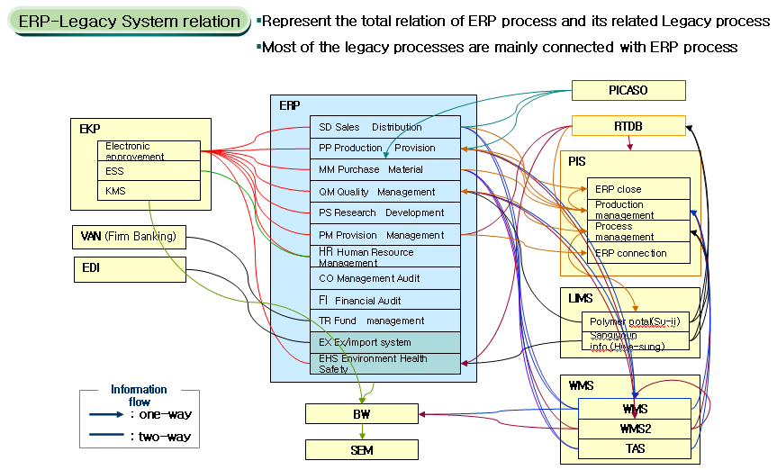

Now, Quantitative Process Analysis, the core part of this research is described in <Table 1>. The workloads of each process based on team members were investigated, reflected the cost and business benefit, investigated the IT resource buying price and development cost and finally, re-distributed to appropriate process.

Figure 4: Quantitative BIA Model
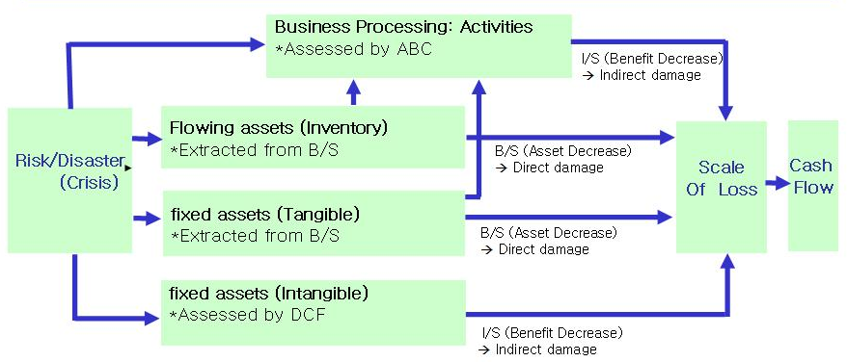

Table 1: Criterion of Operation Process Valuation
 | Criterion of operation process valuation
ABC  Cost analysis technique | 1. Personnel expense distributed to appropriate process (base on personnel process workloads)  2. The expense from each team distributed to appropriate team process (base on personnel expense)  3. Total Business benefits distributed to all process (base on personnel expense)  4. IT resource/development cost distributed to appropriate process (on operation impact rate)  5. Evaluate the sum of distribution cost of each process

Figure 5: Distribution for Expense and Benefit
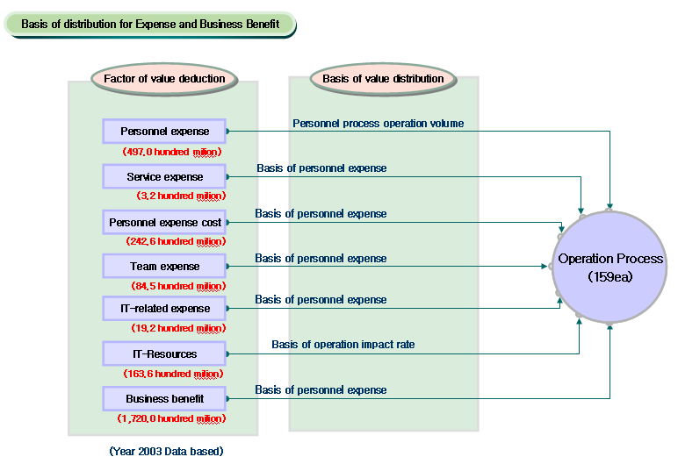
Using those processes of each operation obtained by this research, it was possible to compute the amount of quantitative operation impact as we reflected before/after process interrelation analysis value (Figure 5).

Figure 6: Quantitative Value for Systems
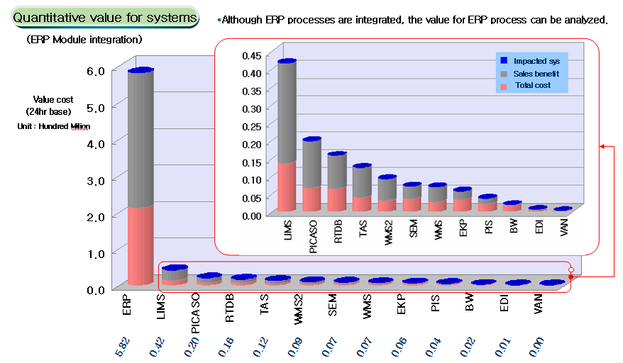

The quantitative value of each process module is computed, and so the value of relevant operation modules is also computed. By using those figures and adding the stoppage time of process module with estimated damage value, the estimated damage value for each system were calculated. Figure 6 indicates that each system shows its value.

Also, according to those values, system unit operation recovery prioritized rank (Figure 8) and system recovery time object in between DR Center construction are indicated.

Figure 7: Strategy of data recovery center
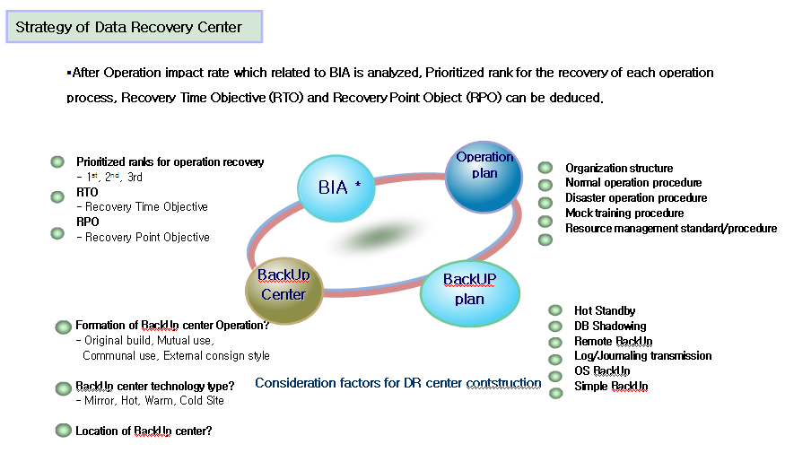
Figure 8: Prioritized Rank
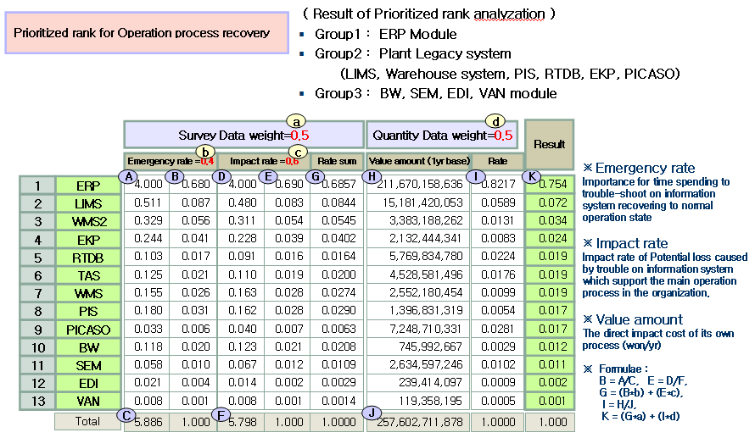

By the results, HPC may bring a loss of half million US Dollar per day if the whole system operations are stopped for 24 hours, so any operations and financial works are stopped.

HPC has decided RTO which is the amount of times that minimize the damage and recover the operation back to normal standard level as 1 day (24 hours) by doing operation impact decision making analysis and interviews.

However, since the finance industry, especially the banks that have high transaction dealing cases rate, consider seriously on RPO which is the value that closely related to data loss, HPC set the RPO as under 2 hours since they have a little reserve time as they are in equipment industry.

Figure 9: ERP Module Value
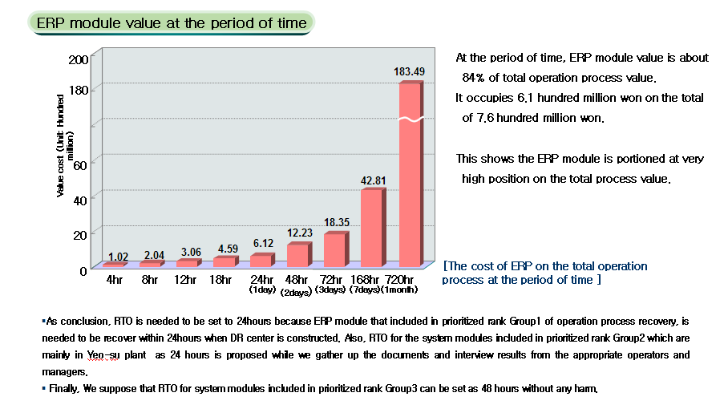
HPC invested 2 million US Dollar to build DR IT Center at the distance of 130KM away. We drew the conclusion that when IT center is in disaster situation for 1 month (30days) without any preparation and financial, sales, and production affairs are all stopped, the ROI is satisfactory (Figure 10).

Figure 10: Effect on DR
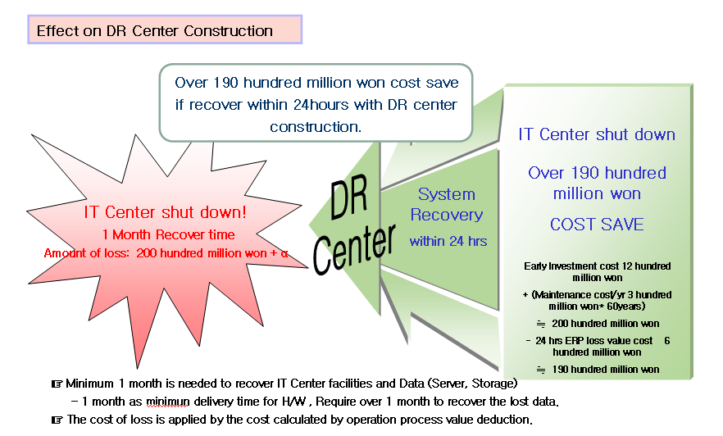

Summary and Conclusion
This research produced two marvellous main outcomes. First, this was the first try of cause-analysis approach which was generally detailed about IT risk analysis in Korea that highly IT developed and rapid growing in recent 10 years.

Second, on IT BIA point of view, there is a significance that it was the first time to try to apply the quantitative analysis which make prioritized ranks between data analysis or relative investment merits on trouble-shooting, transcending Qualitative analysis, to get the results from the damage on processes, unit system program and unit system.

However, suggestions that complement for the better future research are arisen.
The research of risk assessment model is needed to be further progressed to represent the IT operation continuity. Also, the techniques used to analyze in this research like, Process Innovation are needed to be overcome the limit of dependence on ERP system regarding cost price division.

Also, to reflect the additional or immaterial value applied in IT system to the analysis, apart from the values measured used in this research such as IT related asset value, IT related cost, business benefit, direct personnel expense, service cost, personnel/team expenses, we suppose that AHP technique and Monte-Carlo simulation etc. are might needed to use.

Reference
National Computerization Agency (2004) Guideline for Incident & Problem Management of Information System

Youn, Ju-Yong, (1999) “A Study on Crisis Management System for Information Technology,” Doctoral Dissertation

Lee, Young-Jai & Youn, Jong-Won, (2004) An Introduction to Business Continuity Planning, Digital Times

Lee Young-Jai, (1999) “Critical Issue for Business Area Impact Analysis in Business Crisis Management,” In: TIEMS Conference Proceedings 1999.

Chairman of TIEMS KOREA Chapter / Chairman of KOREA Business Continuity Plan Associative 26-3-ga Pil-Dong, Chung-gu, Dongguk University, Seoul, Korea 100-715 Off) 82-2-2260-3297
IT Security Team Manager, Lotte Data Communication Company Doctoral student of MIS, Graduate School of Dongguk University Off) 82-2-2102-1401

