Computer Supported Virtual Organizations: Building a New Type of Public-Private Partnership to Meet the Need of Disaster Victims

Janet Dilling, Carrie Blanchard, Claire Connolly, and Audrey Heffron
Florida State University

Key Words: Virtual Organizations, Atlantic Hurricanes, Temporary Disaster Housing, Post Disaster Construction, Computer-Supported Cooperative Work, and Computer-Mediated Communication

Abstract
The 2004 Atlantic Hurricane Season has been one of the busiest and most destructive in history. Although paling in human terms in comparison to the recent Asian Tsunami with its sobering loss of life, the Atlantic Hurricanes have generated the largest response and recovery effort in U.S. history with damage estimates exceeding $42 billion.

This paper will discuss two unique public-private partnerships, which operating as computer supported virtual organizations helped redefine state and federal response relating to post disaster construction and temporary housing issues in a disaster. In doing so, the paper will expand collaborative information technology (CIT). The term CIT is used to denote asynchronous technology that provides support for coordination and collaboration through computer supported communication. Although CIT, closely related Computer Mediated Communication (CMC), and Computer Supported Cooperative Work (CSCW) are usually associated with constructing or managing interorganizational communication, this paper will explore how web based technology bridged the information gap between government, the private sector, and victims left homeless by this series of catastrophic hurricanes.

Introduction
The 2004 Atlantic Hurricane Season has been one of the busiest and most destructive in history. Although paling in human terms in comparison to the recent Asian Tsunami with its sobering loss of life, the Atlantic Hurricanes have generated the largest response and recovery effort in U.S. history with damage estimates exceeding $42 billion.

This paper will discuss two unique public-private partnerships, which operating as computer supported virtual organizations helped redefine state and federal response relating to post disaster construction and temporary housing issues in a disaster. In doing so, the paper will expand collaborative information technology (CIT). The term CIT is used to denote asynchronous technology that provides support for coordination and collaboration through computer supported communication. Although CIT, closely related Computer Mediated Communication (CMC) and Computer Supported Cooperative Work (CSCW) are usually associated with constructing or managing interorganizational communication, this paper will explore how web based technology bridged the information gap between government, the private sector, and victims left homeless by this series of catastrophic hurricanes.

The Need for Information in a Disaster
Access to information is critical in a disaster situation. Governmental and non-governmental response agencies use it for guiding decision-making and response actions; the private sector and the public use it to acquire aid and resources. Citizens’ information needs are a public good and service central to virtually all of government’s response and recovery efforts.

During the 2004 Atlantic Hurricane Season, two unique public-private partnerships, the Disaster Contractors Network and Disaster Housing Resources Online, fulfilled the definitions of CMC and CSCW by conveying information to disaster victims and those who sought to help them. In each instance, these public-private virtual organizations, using web-based computer served systems, linked government, the private sector, and disaster victims with information to help speed the recovery process.

Communication and coordination, the “two c’s”, are repeatedly cited as the two areas needing the most improvement in disaster response and recovery operations. Often at the core of each of these is the transmittal or translation of information. Information here can be defined as the communication or reception of knowledge and intelligence during the disaster and post disaster event and the process by which knowledge is impressed upon others. Increasingly this communication and coordination of information is accomplished with the assistance of computer technology in an Emergency Operations Center, Command Post, or via the World Wide Web.

Describing communication technology
Using technology to fill information needs is not a new concept. The first computer-supported social network (CSSN) was in the 1960’s when the U.S. Defense Department’s Advanced Research Projects Agency developed ARPANET to link large university computers and some of their users. The concept of computer supported cooperative work (CSCW) has been used to describe the design, introduction, and use of groupware systems to bridge the dynamics and diversity of different organizations and groups within organizations (Rittenbruch, Kahler, & Cremers, 1998). More descriptive and to the point for this paper is the concept of Computer Mediated Communication (CMC). CMC is the name given to a large set of functions in which computers are used to support human communication (Santoro, 1995). Computer Mediated Communication (CMC) is distinguished by the nature of the human-computer interaction and by the role taken by the computer in mediating the human communication process. The element of CMC explored here is one in which the computer plays an active role as the repository or maintainer of organized information. This information originates or is coordinated by a governmental entity, working with private sector partners, and is utilized by disaster victims and resource providers. Santoro (1995) refers to this as “informatics”. Central to our discussion is the use of computer systems and networks for the transfer, storage and retrieval of information between government agencies, private sector resources, and disaster victims. In our examples, the computer/network system becomes a mediator rather than a processor of the information (Santoro, 1995).

Using virtual organizations to transmit information with low transaction costs
DeSanctis, Gerardine, & Peter Monge, (1999) define virtual organizations (VO) as: “a collection of geographically distributed, functionally and/or culturally diverse entities that are linked by electronic forms of communication and rely on lateral, dynamic relationships for coordination” (DeSanctis, et al, p. 693). These organizations, though bounded by shared goals and a defined identity, may be constantly morphing or reconfiguring the structure and processes of the organization. Virtual Organizations can also be thought of as a “a form of cooperation of legally independent companies or people contributing their core competencies to a vertical or horizontal integration and appearing as one organization to the customer” (Rittenbruch, Markus, Kahler Helge, & Armin B. Cremers, 1998, p. 30).

The success of virtual organizations hinge on shared, interdependent processes that are designed to achieve shared objectives (Grabowski, et al., 1999). The communication benefits include reaching a larger geographical area, larger participation rates, and being more efficient, i.e., a faster response time and task specialization (DeSantis, et al, p. 694). A downside of VO communication is the organization’s struggle to maintain a coherent identity, and the possibility of alienation and information overload for the participants.

Computer networks sufficiently reduce the costs of coordination, allowing virtual organization partner organizations in our examples to achieve active information dissemination and resource coordination without high transaction costs. Transaction cost theory is an interdisciplinary approach that is derived from three different, but related literatures: economics, organization theory, and contract law (Williamson, 1981 p.573). Williamson defines a transaction as an event whereby “a good or service is transferred across a technologically separable interface” (1981, p.552). The good or service here is information on steps to take after the disaster and a series of databases containing service, material or temporary housing providers. The more complete information available to the participant, the lower the costs, risk, and uncertainty levels in the transaction process (Maser, 1998). Here information technology is being used to provide a time and cost efficient way of disseminating and obtaining information regarding a resource transaction, in addition to decreasing the spatial distribution of the exchange. Information technology operating within virtual organizations, then, lower transaction costs and encourage interaction. With both DCN and DHROnline this translates into using collaborative information technology to exchange information and disaster intelligence between resource providers and victims. After the occurrence of a significant natural disaster such as the series of hurricanes in 2004, these efficient exchanges help stimulate the activity that will result in recovery efforts to the benefit of the affected communities. Therefore, the use of computers and the World Wide Web to coordinate and disseminate information can be thought of in terms of transaction cost theory.

The Disaster Contractors Network and Disaster Housing Resources Online

The Disaster Contractors Network

The construction industry is a valuable resource to government and its citizens in a disaster. The Disaster Contractor Network (DCN) is a vehicle for helping contractors maximize their impact on the governmental and private sector response. DCN does this, first, prior to a disaster, in encouraging businesses and homeowners to employ mitigation measures, and secondly, post- disaster, when they can both help prevent secondary damage with more rapid re-building and assist their customers in building back better using mitigation techniques. The Disaster Contractor Network (DCN) is an unprecedented partnership between the Associated Builders and Contractors of Florida (ABC), the Florida Roofing, Sheet Metal and Air Conditioning Contractors Association (FRSA); the Association of General Contractors (AGC); the Florida Home Builders Association (FHBA); the Center for Disaster Risk Policy (CDRP) at Florida State University; the Federal Emergency Management Agency (FEMA), Region IV; the State of Florida Department of Community Affairs and the State of Florida Department of Business and Professional Regulation. Underwritten largely by the Department of Community Affairs and FEMA, the DCN is the first attempt anywhere in the United States to coordinate contractor associations through their existing state and local networks. The network provides access to disaster construction related information and trains local associations of the major contractor organizations in the State of Florida in disaster management issues. During actual disaster activation the DCN consolidates disaster intelligence from all its partner organizations and disseminates it over a website, www.dcnonline.org in the form of situation reports and hot issue postings. Therefore the virtual organization structure is used to coordinate multiple public and private sector agencies and organizations. It also uses a DCN virtual operations center to match critical building or labour needs with available construction and construction material resources to help speed the re-building effort. Updated information on licensing and permitting issues, constantly changing after a major disaster, are also posted by county. Often the cost of obtaining information, from government sources in particular, can be so costly in time and effort as to prohibit citizens from seeking additional information regarding the steps they should take, i.e., a transaction (Maser, 1998). Because Internet-based virtual organizations have a relatively low cost-benefit ratio (cost of obtaining additional information to the benefit of reduced uncertainty) the availability of virtual organizations such as DCN and DHROnline encourage the disaster victims to obtain information, thus making it more likely that the information transaction will actually occur. Furthermore, there are few costs associated with using information technology to seek out and monitor a transaction partner for citizens in a technologically advanced society such as the United States - for most, the Internet search process is relatively easy and time efficient.

In the summer and fall of 2004, the potential of the DCN was recently fully realized by taking the partnership from the level of a web based training and information portal to successfully integrating the contractor community and the emergency management community into the recovery and mitigation process of four Atlantic hurricanes. This was accomplished through contractor’s direct involvement in state and local disaster operation centers and field offices, intelligence gathering regarding post storm conditions, and the coordination of eight construction fairs in heavily impacted areas to help the re-building effort.

Prior to the 2004 activation the objectives of the Disaster Contractor Network had been to:
- Develop a “disaster smart” contractor.
- Establish a training and information medium for contractors regarding mitigation and disaster operations.
- Achieve incorporation of “DCN” into everyday vernacular among contractors and their associations.
- Create a model public/private partnership between government and the contractor community.
- Provide a medium of direct dialogue between contractors and government during disaster response and recovery.
- Provide identification and support of critical needs and resources to the contractor community during disaster events.
- Serve as a conduit between Federal, State, local, regulatory agency, building associations, and the contractor community.
During the recent activation however, it was soon recognized that providing direct information to the impacted homeowner in a post disaster environment became paramount after disaster victims discovered the DCN website. Between August 13, 2004 and February 13, 2005 the DCN website experienced over 4,866,873 hits to its website from both contractors and homeowners. See Figure 1.

Average hits per day totalled 26,307 for this period with the highest concentration of hits occurring in September 2004, with over two million hits for that month. Homeowners found the site through a series of outreach activities at thirty-one Disaster Recovery Centers and at DCN special events at local home building supply providers. Traffic to the website peaked on September 21, 2004 with 188,000 hits in one day. Over 9,643 available resources to aid in the re-building effort were posted by contractors during that period. This is even more remarkable in that the 2004 season represented the first time the DCN was activated for a disaster event. Using a distributed network of databases and construction related knowledge DCN provided the capacity to search for and retrieve information on resources that would help both contractors working in the field and homeowners requiring repair or re-building services. It also linked mitigation to recovery activities both on the web site and through a series of outreach publications distributed in the field. In addition to homeowners, the information exchange benefited local government licensing and permitting organizations. Seeing very quickly that no mechanism was in place to coordinate the myriad of temporary changes in permitting and licensing requirements at the local level, the DCN modified its Virtual Operations Center to provide a venue for local citizens and contractors to access those changes. The DCN was adaptive in scaling knowledge for action at multiple levels.

The DCN includes on its site a mechanism in which consumers can check the state licensing status of a potential contractor provider. This is accomplished working closely with one of the partner organizations, the Department of Business and Professional Regulation, which serves as the state-licensing agency. This is an example of where collaborative information technology has the potential to significantly reduce the transaction costs in a disaster. This is accomplished when resources are scarce by providing information regarding the value and quality of the product or service as well as information about the seller to the consumer. When more information is known about a contractor, the consumer is likely to feel a greater trust because the uncertainty of the transaction is minimized. Thus, according to transaction cost theory, when trust is established between the consumer and provider the exchange is more likely to occur (Frant, 1996).

Computer-supported social networks (CSSN) are mostly used to communicate the exchange of information with people posting a question or comment and receiving information in return. With DCN both questions and resource requests were posted. It allowed for increased access to experienced, skilled people in government for questions and access to the private sector for services. An argument may also be made that DCN offered emotional support as well as access to goods and services during a disaster. Seeing that government and private sector professionals are there to help, those participating in DCN may have felt that they were not alone during the stress following the disaster. Research has shown that, “despite the limited social presence of CMC, people find social support, companionship, and a sense of belonging through the normal course of CSSNs of work and community, even when they are composed of persons they hardly know” (Wellman, et al., 1996, p. 220).

Disaster Housing Resources Online

Another critical problem with the large numbers of homes that were damaged and destroyed by the 2004 hurricanes in Florida was the issue of finding temporary housing for the thousands of victims left without a place to live. After seeing the success of DCN and the ease of which it could be administered in times of disaster by FEMA reservists, FEMA contacted the Center for Disaster Risk Policy to apply the DCN model to this issue. DHROnline was the result. Built on the same premise of creating a virtual organization that could muster information and resources of multiple organizations the DHROnline was molded together in ten days to help fill critical housing needs. In addition to FEMA and the Center for Disaster Risk Policy, the Florida Housing Finance Corporation and the Florida Association of Realtors were brought on as partners because of their access to housing providers who could list properties on the site. The DHROnline was developed to help displaced victims find housing quickly and easily. Prior to DHROnline going live, disaster victims would call a FEMA hotline and be provided available property listings from a FEMA inventory by call center operators. In September and October call volumes were in the thousands per day, with FEMA operators spending long amounts of time going over property listings with victims. DHROnline uses a searchable website to allow victims to not only access the thousands of properties FEMA has in their inventory but also others that could be posted with full property descriptions and photos by property managers and realtors. Advanced searches were possible allowing call center operators to provide victims with DHROnline website address, with full confidence that they would be able to find a property within their budget and with amenities needed by their family. See Figure 2.

Figure 2 – The Advanced Search Function of DHROnline
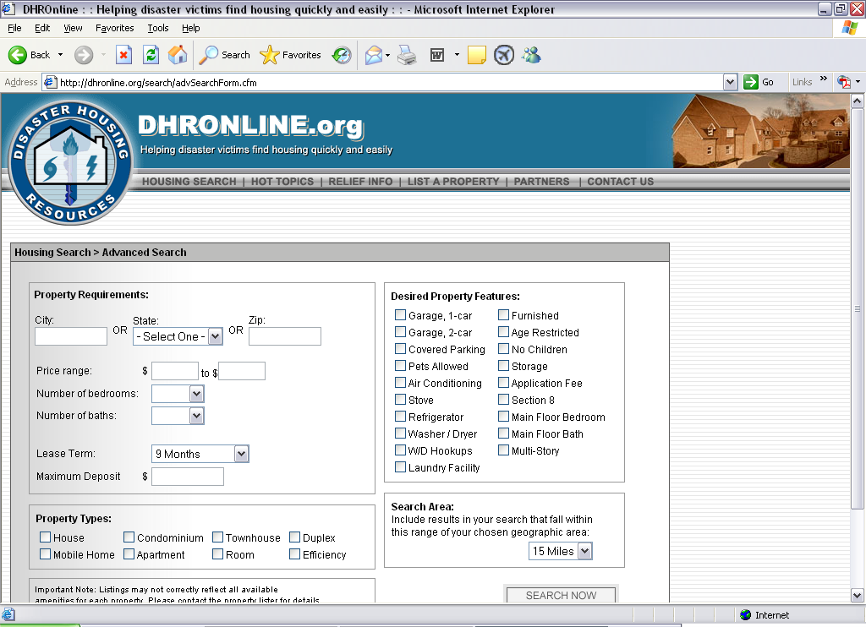

“The structure of the Net encourages specialized relationships because it supports a market approach to finding social resources in virtual communities. With more ease than in almost all real life situations, people can shop for resources from the safety and comfort of their homes or offices, and with reduced search and travel time” (Wellman, et al., p. 221). This reduces time spent on the phones with FEMA and state agencies, thus reducing the transaction cost of the information.

Summary
In a 1996 study Barry Wellman and his co-authors cautioned against the overuse of computer mediated communication because they were concerned with “the effects of losing verbal nuances (e.g. voice tone, volume), nonverbal cues (e.g. gaze, body language), physical context (e.g. meeting sites, seating arrangements), and observable information about social characteristics (e.g. age, gender, race)” (Wellman, Barry, Janet Salaff, Dimitrina Dimitrova, Laura Garton, Milena Gulia, & Caroline Haythornthwaite, 1996, p. 218). However, there are benefits to what can be gained using information technology and virtual organizations this way. For example, it is one thing to tell a person over the phone about an apartment/service that is available to them and another for that person to see the photos of the apartment/service on-line. Although the authors state that “some participants prefer in-person contact to CMC for ambiguous, socially sensitive, and intellectually difficult interactions” (Wellman, et al. p. 218), CIT and CMC has the advantage of maintaining social distance, documenting contentious issues, providing more complete information, and allowing numerous parties various distances apart to communicate together simultaneously.

DCN and DHR are ultimately public goods and services required to meet citizens’ demands and preferences for critical disaster information and resources. In each instance victims, service providers, and government agencies are linked in a working virtual organization to solve disaster response and recovery problems. Disparate organizations are able to coordinate with one another in a dynamic but boundaried organization to meet the needs of the partner organizations and the constituencies they serve.

References
Coase, R.H. (1937) “The Nature of the Firm”, Economica, New Series, Vol. 4, No. 16 (Nov., 1937), 386-405.

Coase, R.H. (1960) “The Problem of Social Cost”, Journal of Law and Economics, Vol. 3 (Oct., 1960), 1-44.

DeSanctis, Gerardine, & Peter Monge. (1999). “Introduction to the special issue: communication processes for virtual organizations.” Organization Science, 10, 693-703.

Frant, Howard. (1996) “High- Powered and Low-Powered Incentives in the Public Sector”, Journal of Public Administration Research and Theory: J-PART, Vol. 6, No. 3, (July, 1996), 365-381.

Grabowski, Martha, & Karlene H. Roberts. (1999). “Risk mitigation in virtual organizations.” Organization Science, 10, 704-721.

Kraut, Robert, Charles Steinfield, Alice P. Chan, Brian Butler, & Anne Hoag. (1999). “Coordination and Virtualization: The Role of Electronic Networks and Personal Relationships.” Organization Science, 10, 722-740.

Maser, Steven M. (1998) “Constitutions As Relational Contracts: Explaining Procedural Safegaurds in Municipal Charters”, Journal of Public Adminstration and Research Theory: J-PART, Vol. 8, No.4 (Oct., 1998), 527-564.
North, Douglass C. (2004) Institutions, Institutional Change and Economic Performance. Cambridge University Press: New York, 2004.

Rittenbruch, Markus, Kahler Helge, & Armin B. Cremers. (1998). “Supporting cooperation in a virtual organization.” Proceedings of ICIS, 30-38.

Wellman, Barry, Janet Salaff, Dimitrina Dimitrova, Laura Garton, Milena Gulia, & Caroline Haythornthwaite. (1996). “Computer networks as social networks: collaborative work, telework, and virtual community.” Annual Review of Sociology, 22, 213-238.

Weintraub, Roy E. (2002) “Neoclassical Economics” [Online] Available from: www.econlib.org. 2002.

Williamson, Oliver E. (1979) “Transaction-Cost Economics: The Governance of Contractual Relations”, Journal of Law and Economics, Vol. 22, No. 2 (Oct., 1979), 233-261.

Williamson, Oliver E. (1981) “The Economics of Organization: The Transaction Cost Approach”, The American Journal of Sociology, Vol. 87, No. 3 (Nov., 1981), 548-577.

Williamson, Oliver E. (1988) “The Logic of Economic Organization”, Journal of Law, Economics, & Organization, Vol.4, No. 1 (Spring, 1988), 65-93

Author Biographies
Janet Dilling is the Director of the Center for Disaster Risk Policy at Florida State University where she specializes in emergency management, program evaluation, and organizational development. Janet is also the Director of the Emergency Management Graduate and Undergraduate Certificate Program at Florida State University where she is a principal faculty member for the Askew School of Public Administration and Policy’s emergency management curriculum.

Carrie Blanchard is a Research Analyst for the Florida Public Affairs Center and the Center for Disaster Risk Policy at Florida State University. Before receiving her Master’s degree from the University of Miami in Public Administration, Ms. Blanchard served as an AmeriCorps VISTA working in children’s healthcare policy. Currently Ms. Blanchard is a doctoral student at the Askew School of Public Administration and Policy at Florida State University.

Claire Connolly is a Research Analyst with the Florida Public Affairs Center and the Center for Disaster Risk Policy at Florida State University. She is a doctoral student in the Askew School of Public Administration and Policy focusing on Environmental Public Policy. Formerly with the USGS National Wetlands Research Center, Ms. Connolly was an Interpretative Specialist for the Coastal Wetlands Planning, Protection, and Restoration Act. She is a graduate of the University of Louisiana at Lafayette.

Audrey Heffron is Deputy Director of the Center for Disaster Risk Policy at Florida State University. She is a professor of terrorism studies and specializes in the areas of government recovery and policy planning for disasters. Audrey has served on several national boards including a national task force on Volunteer Response During Disasters.

Florida Public Affairs Center and the Center for Disaster Risk Policy, Florida State University, Tallahassee, Florida 32306-2250

