Analysing Interdependencies of Critical Infrastructures

Using Agent Discrete Event Simulation

Claudio Balducelli, Sandro Bologna, Antonio Di Pietro, Giordano Vicoli
Italian National Agency for new Technologies, Energy and the Environment (ENEA)

Keywords: Critical Infrastructures, interdependency, discrete event simulation, agent-based simulation, fuzzy rules

Abstract
The paper explores the possibility of using interacting agents for modelling and discrete event simulation as a tool to approach interdependencies analysis and evaluation for Critical Infrastructures. A discrete event simulation system was developed, using agent oriented programming, considering the following limited sets of critical infrastructures: a great hospital infrastructure, a railway transportation infrastructure, other public transportation infrastructures.

Faults inside the electricity distribution system are simulated, producing electrical power outages whose duration could be variable respect time and space, and generating consequences inside the transportation infrastructures.

The hospital infrastructure users, like different types of physicians, nurses, subsidiary personnel, students, patients are also considered inside the generated scenarios. Objective of the simulations is the to study and analyse the interdependencies of the considered infrastructures, caused also by the delays that the blackouts produce in the arrivals and leavings of users to/from the hospital infrastructure.

To model in the right way the users behaviours, a set of preference rules with an associated fuzzy logic mechanism, are also implemented as part of the simulated environment.

Many typologies of test scenarios are executed and the severity of the generated consequences are analysed in the paper.

Introduction
The increasing complexity and interconnectedness of Large Complex Critical Infrastructures (LCCIs) and their supporting Networked Information Intensive Systems (NIISs) pose new challenges for modelling and analysis of the survivability of the systems. Newly emerging properties have to be understood, represented and analysed. While important steps have been taken on individual infrastructures, issues like interdependence and cascading effects among infrastructures have received much less attention. Not even is an exhaustive classification of possible types of failures available or in development. This situation calls for concerted efforts for an exploration of new methods and tools.

The various aspects of interactive infrastructure networks present numerous theoretical and practical challenges in modelling, simulation, prediction, and analysis in coupled and uncoupled systems. These systems comprise a heterogeneous mixture of dynamic, interactive, and often non-linear entities, unscheduled discontinuities, and numerous other significant effects. Existing mathematical models of such systems are vague and no methodologies for the understanding of the behaviour of these complex systems exist. The science of complex systems as well as chaos theory with attributes like entropy and complexity is considered particularly relevant to the study of topological properties and emerging behaviour of such interactive infrastructures. One of the problems we are facing in this domain is similar to those of fractals. Partitioning them into even smaller1 parts does not simplify the problem. Take, e.g., a power grid with a variety of production, switching, and transmission stations. A compartmentalisation of these stations or even a break down on a lower level does not lead to a better understanding or ability to protect anything. Additionally, in many complex networks, the human participants are both the most susceptible to failure and the most adaptable in management and recovery. Thus, modelling these networks will need to include the bounded rationality of actual human thinking. Furthermore, modelling will need to be carried out at a range of different resolutions, to achieve the overall objective of survivability analyses.
The following list of complications illustrates that networks representing LCCIs are inherently difficult to understand [1]

- Structural complexity: increasing number of nodes and links between nodes.
- Network evolution: the link between nodes could change dynamically over time.
- Connection diversity: the links between nodes could have different weights, directions and signs.
- Dynamical complexity: the nodes could be non-linear dynamical systems. In a network the state of each node can vary in time in complicated ways.
- Node diversity: there could be many different kinds of nodes in distributed, open systems.
- Meta-complication: the various possible complications can influence each other. For example, the present layout of a power grid depends on how it has grown over the years – here network evolution affects topology.

Fig 1 – Layer decomposition of an LCCI
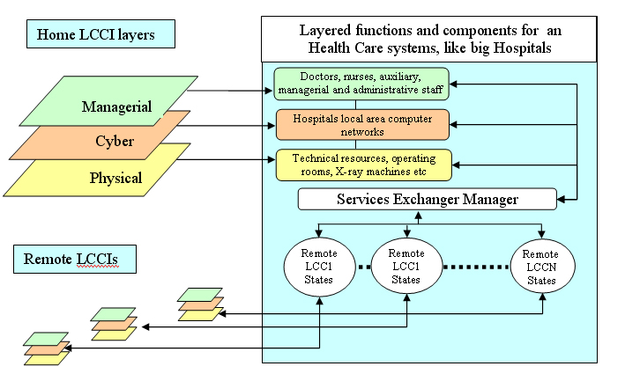

Generically, we may represent the domain of interest in three layers (see left part of fig. 1)[2][3][4].

- The “Physical” infrastructure layer made by the components producing the infrastructures physical services;
- The “Cyber” automation and control layer made by hardware and software computer machines producing software services;
- The “Managerial” layer made by human organisation that utilise the components of other two layers to operate the entire infrastructure;

Layers 2 and 3 form part of the LCCI supporting the physical infrastructure, and correspond to the management and control/supervisory sections. Such layers could be more or less complex depending on the degree of automation of the infrastructure. In the right part of fig. 1 are evidenced the functions carried out at this level by an Health Care infrastructure like a big Hospital, that is in such case considered as the “Home LCCI”.

It is useful to see that every infrastructure produce and utilise a set of “services” to/from may other LCCIs (Electricity, Transportation, Telecommunication etc.), and that the nature of such services may be very different in relation with the typology of the considered infrastructure. In case of a railway transport system the produced service is the transportation of users at their destination while the requested services are electrical energy supply, telecommunication availability etc. If we consider a Health Care infrastructure as remote LCCIs, obviously it is strong dependent by a railway infrastructure considered as Home LCCI because the availability of the Hospital personnel depends on the train’s availability.
Such considerations suggest that different types of simplifications, according to the kind of the properties we want to study, for example static vs. dynamics properties, will be necessary. Assuming that we have methods and tools to study different properties of an available network, the follow-on question arises: if we couple many such systems, what can be said about their collective behaviour? The answer we could provide is: not much. It will be a function of different complications that will characterise the single system network.

A Methodology for Modelling and Simulating LCCI’s Interdependencies
All critical infrastructures have one property in common – they are all complex collections of interacting components in which change often occurs as a result of learning processes; that is, they are Complex Adaptive Systems (CAS) [5]. Seen from this perspective each component of an infrastructure constitutes a small part of the intricate web that forms the overall infrastructure. From a CAS perspective, infrastructures are more than just an aggregation of their components. Typically, as large sets of components are brought together and interact with one another, synergies emerge. This additional complexity exhibited by a system as a whole, beyond the simple sum of its parts, is called emergent behaviour and is a hallmark of CAS. CAS does not require strong central control for emergent behaviours to arise.

One effective way to investigate CAS is to view them as populations of interacting agents, where an agent is an entity with a location, capabilities, and memory. Agents communicate with one another as they operate in a particular environment. Each agent receives inputs from other agents and sends outputs to them. One powerful computational approach to understanding CAS is agent-based modelling and simulation (ABMS). An ABMS consists of a set of agents and a framework for simulating their decisions and interactions [6][7].

When examining the more general case of multiple infrastructures connected as “system of systems”, we must consider interdependencies. Infrastructures are frequently connected at multiple points through a wide variety of mechanisms, such that bi-directional relationship exists between the states of any given pair of infrastructures; that is, infrastructure i depends on j through some links, and j likewise depends on i through other links. It means to consider connections among agents in different infrastructures, with a dramatically increase of the overall complexity [8]. Unfortunately, the science of infrastructure interdependencies is relatively immature. Developing a comprehensive architecture or framework for interdependency modelling and simulation is a major challenge. Many models and computer simulations exist for aspects of individual infrastructures, but simulation frameworks that allow the coupling of multiple interdependent infrastructures are only to be considered.
Modelling is necessary to understand the dynamic behaviour of LCCIs and their interdependencies. Currently, there are no mathematical models that can generate useful top-down models for these systems that are models that start from large-scale graphs, systematically map them into de-coupled sub-systems, and investigate the interactions between them.
Because of the variety of components and potential interactions, deriving all-encompassing rules for complex infrastructures is impractical. Therefore, top-down models offer some insight but can’t adequately reflect real-world situations for complex infrastructures. Traditional top-down models use algebraic/differential equations to simulate aggregate populations within complex system. Specific internal mechanisms such as adaptation and learning are ignored.
An alternative would be to develop a bottom-up approach using autonomous adaptive agents, which allow implementation for the individual parts of a system. By concentrating on smaller parts of the system, deriving rules becomes more practical.
Bottom-up models based on autonomous adaptive agents let us evaluate the local mechanisms that produce emergent patterns at system level. Emerging Agent-Based Modelling (ABM) focuses on individual parts of a system rather than the whole; focusing on smaller parts of the system makes rule derivation more practical. Finally, real-world complexity is modelled by letting the individual “agents” interact independently, which can provide a better understanding of local mechanisms that produce emergent behaviour, as opposed to the centralised control inherent in top-down models. This can be undertaken in abduction to system theory. Some part of a LCCI, e.g. an ICT administered power generator, can be modelled as closed system, simplifying the observation in an initial stage and leading to “simpler” rules.
Agent-based models enable the use of simulation to better understand the large-scale, non-linear behaviour of complex infrastructures in the hope of improved amelioration of disturbances and prevention of disastrous cascading effects.
For engineered systems, such simulations can be used as a tool helping to build agent-like characteristics into infrastructure components, so that they can actively respond in their real-world environment automatically, independently, and co-operatively with other components. Development of complex infrastructures that are self-optimising through distributed management and control will come into reach. As these simulations become more detailed and physically realistic, autonomous agents will represent all the individual components of the infrastructure. These agents will evolve, gradually adapting to their changing environment and improving their performance even if conditions change.

The infrastructure components belonging to the different layers defined in the previous section can be modelled using object-oriented methods. This allows to model them as a class of object hierarchies of simpler components as in fig 2, thus creating a hierarchy of adaptive agents [6].

Fig. 2. - The relationship between agent classes and agents 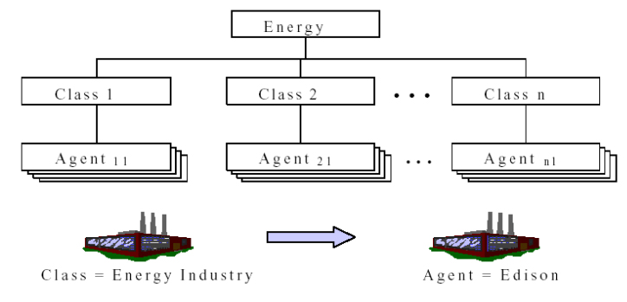

This is possible for the physical components such as a generating plant, substations or electrical lines, but can be also experimented for the cyber or managerial layers: in this work the population belonging to the managerial layer of a big hospital is modelled in such way and its emergent behaviour is analysed to evaluate the potential vulnerabilities produced by the interdependencies between infrastructures.

A Simulation Experiment
For a better understanding of interdependencies that exist between LCCIs, it was designed a simulation model, and implemented in Java language, for a particular class of infrastructures. Such simulator is not based on differential equations, but on logic relationships able to model, in a qualitative way, the human being behaviours during the utilisation of the services furnished by most important urban infrastructures.

The simulation model may be considered as a first tentative to understand in a more formal way the emergent problem of critical infrastructures protection.
The most interesting practical result of such developed simulator is the possibility to apply the developed model in the vulnerability analysis of the real infrastructure aimed to define appropriate countermeasures.

In fig 3 it is shown how the simulation model works. The working state parameters of a set of infrastructure are acquired at a certain time t; then the model makes a first data analysis to determine the initial state of every infrastructure. During a preliminary elaboration phase input data are analysed, the simulation process is executed and, depending also by the people (infrastructures users) decisions, the infrastructures statuses are updated.

Fig. 3 – Infrastructure simulation problem
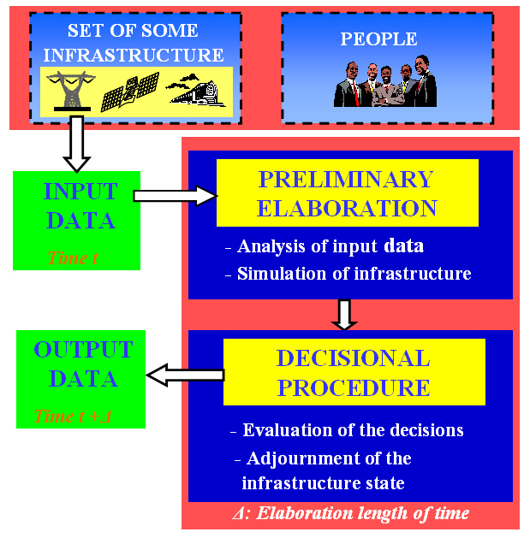

In a further phase the infrastructures states are updated at time t+Δ, the people decision are evaluated, and the effect of failures propagation could be considered.

The methodology used to simulate the human behaviour is based on fuzzy logic. People are modelled by means of a set of fuzzy behavioural rules; they implement a system in which the decisions of a certain person are not deterministic but may vary with a certain degree of uncertainty.

The simulation model is implemented using the agent oriented programming techniques that allow to integrate the two most traditional programming approaches: the distributed programming approach with concurrent programming approach.

In such case it is not applied the distributed approach because the simulator run on a single machine; the concurrent approach is used exploiting the multithreading capability of Window systems: every agent modelling a single infrastructure is associated to a thread that is, by definition, the execution flow of a single process.

The simulator, named SICIMOD (Simulation of Interdependency of Critical Infrastructures and MODelling of the users behaviour), is based on discrete and stochastic simulation techniques. Discrete simulation is essentially based on events instead of on continuous phenomena. Stochastic simulation takes into account probability distributions for a better representation of the real world phenomena.
To build up such simulation environment two working phases are considered:
- The first phase aimed to select the interdependencies between the infrastructures, to define their normal working models and the behaviour of their users;
- The second phase was dedicated to implement the models using Java language with an agent programming technique.

The considered scenario contains the technological infrastructures on which a city is strongly dependent, that are visualised in fig 4.

Fig. 4 – The considered scenario
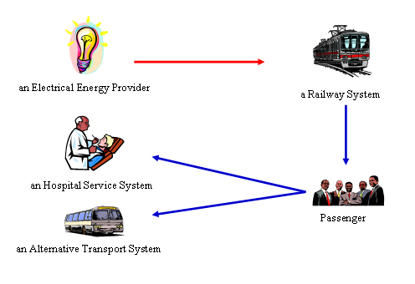
The electrical network gives power supply to a railway transport system: between these two infrastructures an energetic dependency exists because the railway system cannot furnish its service under power outage condition. A second dependency exists between the railway transport system and the train costumers (the passengers); if they cannot utilise the train for a certain time they have to decide some alternative.

The train costumers generate a third interdependency between a Health Care infrastructure (an Hospital) and the Railway System. In fact a large part of the personnel of the Hospital takes the train every day to go to the work, and if a failure of the train system occurs, they will arrive late or, in same cases, they could not arrive at all.

In the same way another interdependency exist between alternative transport system (city Bus) and the railway system. In fact if all train passengers will decide to utilise the Bus such alternative transport system could become congested.

It was considered a scenario in which an electrical power outage happens in some parts of the whole railway path as evidenced in fig. 5; the train passengers was divided in different classes and, for every class a set of fuzzy behavioural rules was defined. For the classes of passengers belonging to the Hospital personnel a time schedule was defined to arrive and leave from working place.

Fig. 5 – A considered railway path containing 9 stations
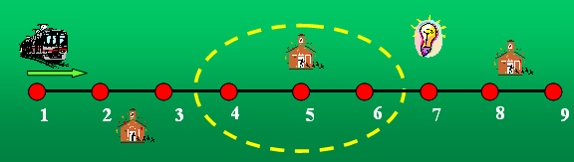

The simulation start at a certain time and with a certain initial conditions: number and classes of passengers waiting at the stations, trains positions, passengers on the trains etc. When the blackout occurs the behavioural rules are applied at every user waiting at the stations with the following options:
- Decide for alternative means of transport (Bus or taxi)
- Go by walk
- Remain waiting to the station

Every option depend from the preference of the specific user for the alternative means of transport; such preference depends from the type of user, about the relevance of his job and how much he/she is late. For such reason different types of alternative means of transport was modelled as bus, taxi, etc.

Regarding the train passengers they are classified using the classes and sub-classes as shown in fig 6:

Fig 6. - Classification of the train passengers as autonomous agents
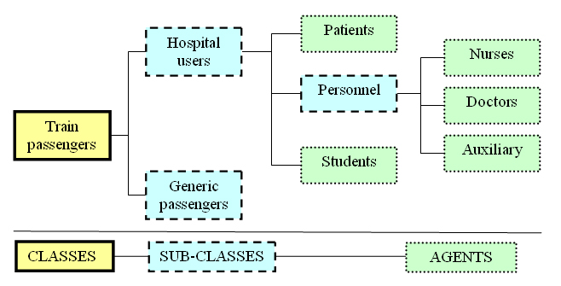

To the generic passengers a generic path is assigned whose goal is to take into account the sum of the paths of all users that are not explicitly modelled. To the categories belonging to the hospital users a specific path and specific sets of fuzzy rules are assigned. Regarding the structure of the defined rules they have two types of input variables:
- Variables related to physical constraints contained in the environment;
- Variables related to sociological constraints proper of the users.

The output variable is determined by the user preference together with a certain degree of fuzziness.

The principal input variable considered by a user of the Hospital waiting at a station is:
- The actual time and the personal time scheduled to arrive and leave from the Hospital;
- The actual waiting time of the user at the station;
- The distance between the station and the Hospital;
- The distance between the station and the passenger home.

To every class of users some preferences are associated in relation with the comforts of means of transport to be chosen;

The principal adopted criteria is that, if a user is late, he/she takes the fasten means, belonging to relative comfort category. The behaviour of every class of users is governed by a set of 36 fuzzy rules: in general some users are more available to wait the reestablishment of the railway functionality while other try to utilise the alternative means of transport.

The rule-based system was firstly designed using the Fuzzy Logic Toolbox of Matlab. A Java agent simulation system was implemented utilizing the NCR Fuzzy Toolkit library realised by the Institute for Information Technology of Canada.

To understand the simulation effects under predefined scenarios the system was tested making use of a graphical tool to display the results; it was possible to evaluate, in real time during the simulation, the number of users waiting at the stations, their decisions, the time they needed to reach their destinations.

Many simulation tests were executed, with scenarios characterised by different power blackouts of different duration, in different hours of the day and in different days. In such way it was possible to analyse in real time the level of delays that different categories of users accumulate to arrive to the hospital and evaluate the consequent emergency problems.

As shown in fig 7, SICIMOD has a graphical interface on which are available, during the simulation, the starting simulation time, the actual time, the power interruption and restarting hours and the length of simulation time (simulation time is faster that the real time). At the actual time it is possible to view the situation of the railway users inside the stations and inside the Hospital.
Is always possible to modify the principal initial parameters like the number of users at the stations, the train’s time schedule or the users arrival time schedule at the Hospital.

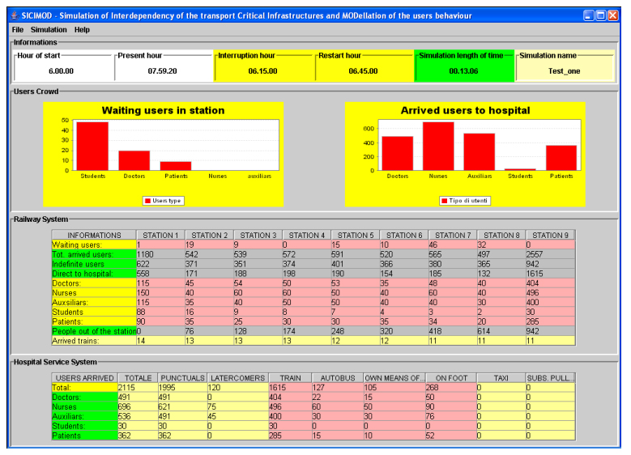
Fig. 7 – A snapshot of SICIMOD simulator

Conclusions
Through the utilisation of SICIMOD it was implemented the possibility to make some estimations about the possible effect caused by the propagation of anomalies and failures between different classes of LCCIs. As the implemented simulation is faster than real time, it allows the preparation of effective countermeasures that are necessary to manage in an optimal way the incoming emergency.

Further improvements may be implemented in the next future inside the simulation system, especially to allow easiest modifications of the characteristics of the infrastructures and to give the possibility to model many other categories of real infrastructure operators and users applying the methods available from social sciences.
With such improvements SICIMOD simulator will be considered not simply as a prototype application but a real decision support system available for Critical Infrastructures stakeholders and operators.

References
ACIP “Analysis and Assessment of Critical Infrastructure Protection”, http://www.eu-acip.de

Balducelli, C., Bologna, S (2002) Agent Based Architectures to Improve Survivability of Large Complex Critical Infrastructures, Proceedings of nine annual Conference of the International Emergency Management Society (TIEMS 2002) Waterloo, Canada, May 2002.

Barton, Dianne C., Analysis of Complexity in Infrastructure Systems Using Agent Based Microsimulation, Infrastructure Surety Department, Sandia National Laboratory, Albuquerque, New Mexico, USA.
http://www.dis.anl.gov/msv/cas/Pubs/Agent2002-InfraInterdepend.PDF.

M. Amin (2000) Towards Self-Healing Infrastructure Systems, Computer, August 2000.

Macal, Charles M., North, Michael J., Simulating Energy Markets and Infrastructure Interdependencies with Agent Based Models, Decision & Information Sciences Division, Argonne National Laboratory, Argonne, IL60439, USA

Rinaldi, S.M., Peerenboom, J. P., Kelly, T.K. (2001) Critical Infrastructure Interdependencies, IEEE Control Systems Magazine, December 2001.

SAFEGUARD, Intelligent Agents Organisations to Enhance Dependability and Survivability of Large Complex Critical Infrastructure, http://www.istsafeguard.org

Strogatz, Steven H (2001) Exploring Complex Networks, Nature, Vol. 410, 8 March 2001, http://tam.cornell.edu/SS_exploring_complex_networks.pdf

Author Biography
Claudio Balducelli is a senior scientist working at ENEA as project manager since 1983 in the field of AI technologies applied to operator decision support systems for emergency industrial accidents. His interests include operator models, knowledge formalization, planning, computerized procedures, plant diagnosis, case based reasoning, and Artificial Intelligence algorithms. He co-ordinated also the prototypical implementation of various site applications like a cooperative training system for the Genoa Oil Port managers (MUSTER project) and an emergency operator support system for major Oil Deposits and Pipelines in Italy. He was also team leader inside SAFEGUARD FP5 project (Safeguarding Critical Infrastructures).

Sandro Bologna, graduated in Physics at University of Rome. From 1972 up today he has been working at ENEA, where he has covered different positions as Researcher, Head of Research Units, Head of Research Projects at national and international levels. His main research activities deal with the achievement and assessment of software intensive systems safety and reliability, operator decision support systems design and assessment, plant control room design and assessment, Large Complex Critical Infrastructures Survivability, Self-healing architectures. In these fields he has co-authored several publications and books.
Sandro Bologna has served the international scientific community in the preparation of Conferences and Journal Special Issues, he has also served EU several times, both as Evaluator and Reviewer of EU Projects.

Giordano Vicoli from 1988 to 1992 took part in research projects in the field of design and development of expert systems for diagnosis and control of industrial plants. From 1993 he has been working in the field of design and development of decision support systems and training applied in emergency management of high risk industrial plants. His interests were in the development of distributed application with J2EE and CORBA technologies. He is actually working inside SAFEGUARD project where he developed the emulated SCADA system environment

Antonio Di Pietro took the degree in Computer Science, specialist in Robotics, at Rome University in 2004. He has a stage of one year at the ENEA research Centre studying and analysing the interdependency problem of Critical Infrastructures.

Via Anguillarese 301, 00060 Rome, Italy, claudio.balducelli@casaccia.enea.it

